**TMC INSTITUTE IN TASHKENT COVER SHEET**



|  |  |  |
| --- | --- | --- |
| Student Name:Makhliyo Yakubova      Student ID: TM221-50 | Module Name: Web programming and application      Module Code: COS107 | |
| Institution : TMC Institute in Tashkent | Deadline:1 **may 2023** | Date of Submission:  1 april 2022 |
| Assessment Type: Individual assignment | Learning Outcomes Assessed: | |

|  |  |  |
| --- | --- | --- |
| Signature of Assessor: | Signature of Moderator: | Overall, Mark (subject to ratification by exam board) |
| This work is fully done by me and I referenced all the sources I used in this work.  Student signature: ___Makhliyo __Yakubova_____________________________  (Type your full name) | | |

**Description about my Orchid’s bookstore website**

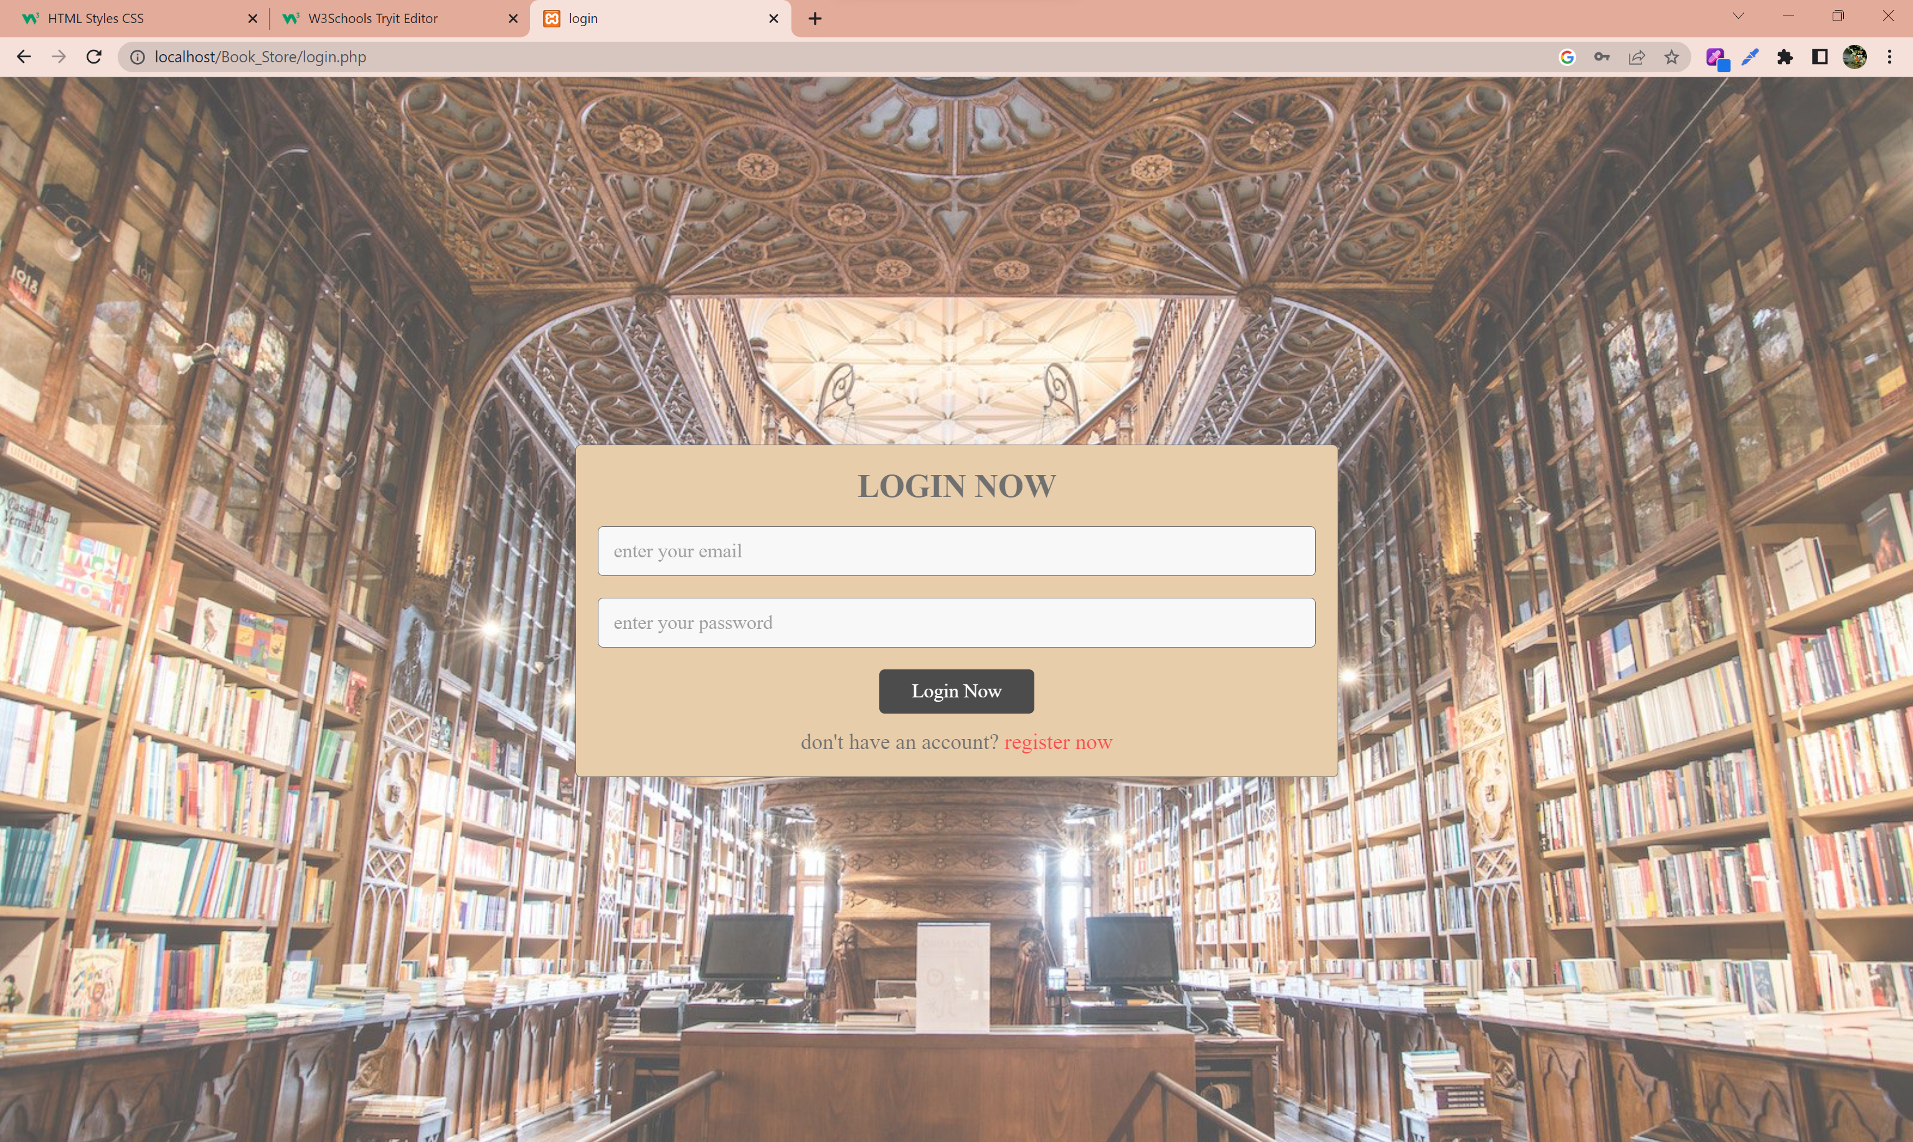

When people first time enter my website log in page appears. Then they don’t have email and password to this website they must pass register page.

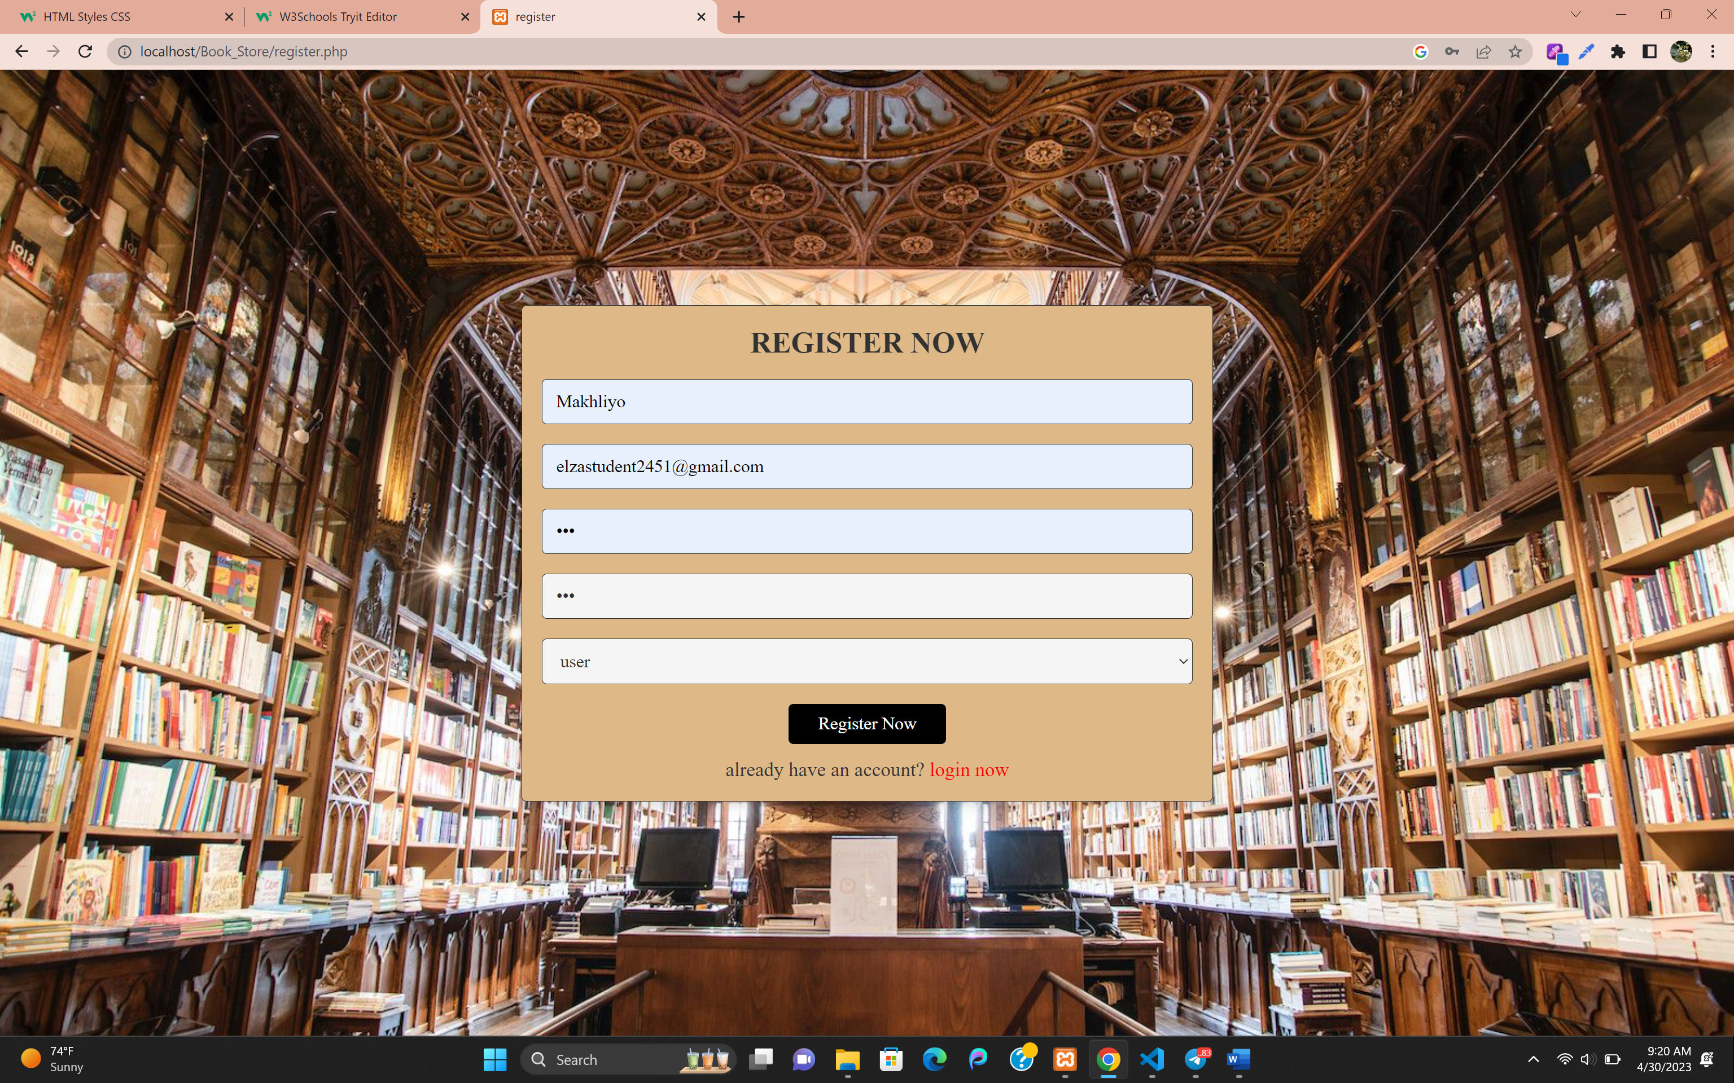

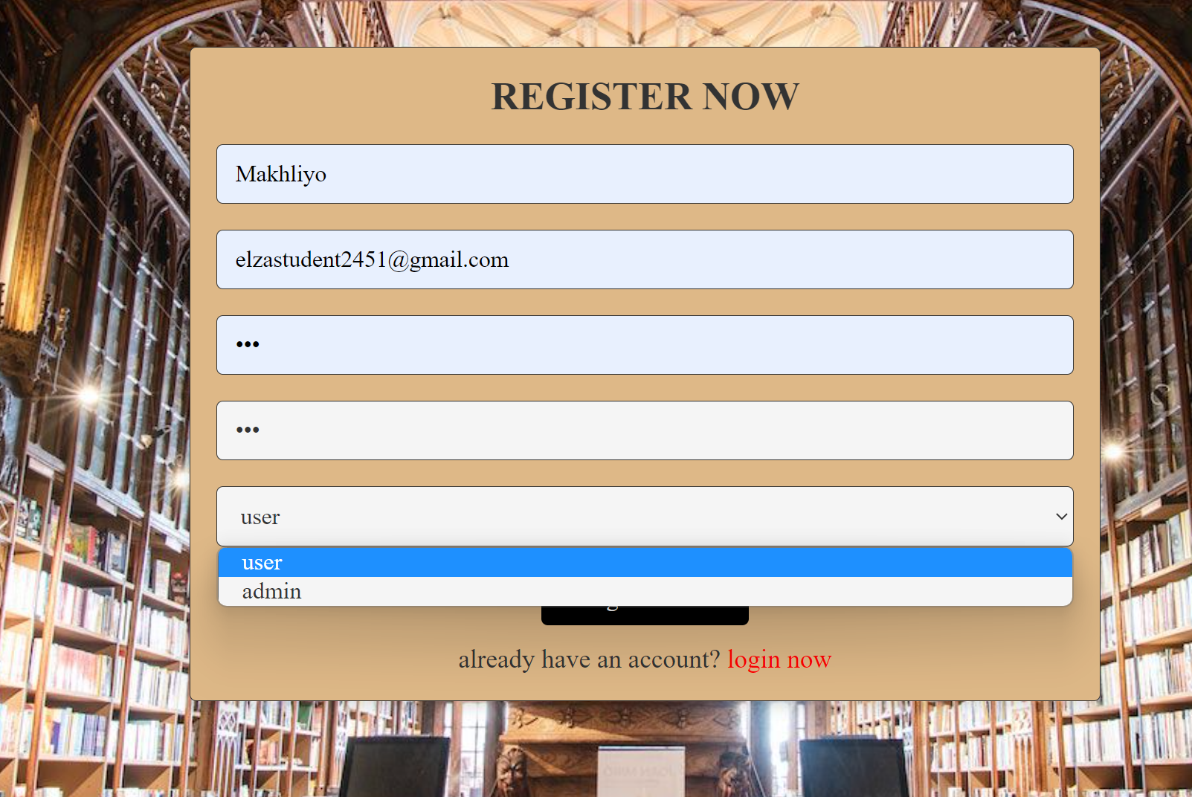

In register page they can choose being an user or admin.

Firstly, I will explain about admin site.

Admin home page

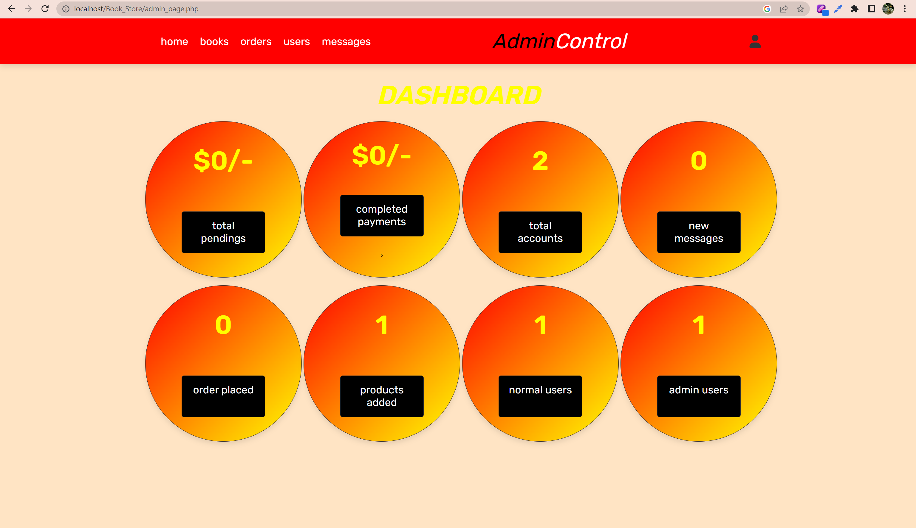

Books page

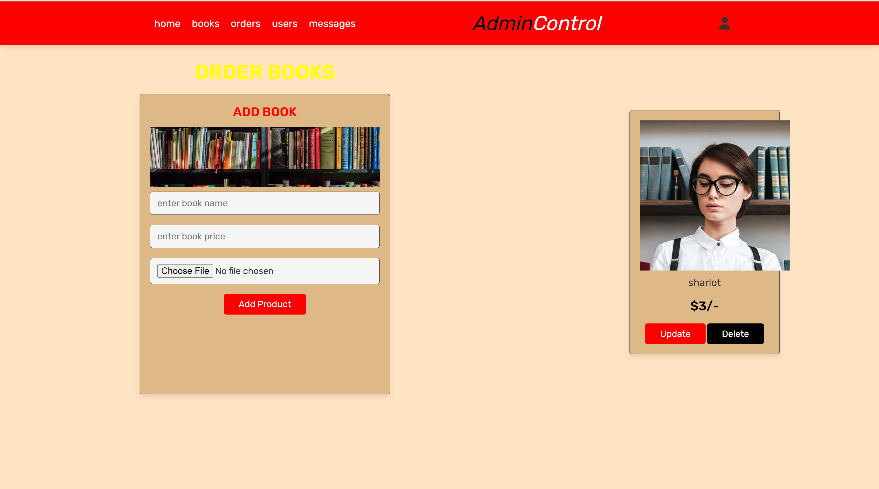

In this page admin can add books . If it is wrong book it has both update and delete buttons.

Orders page

If user send order from user site admin receives it in this page.

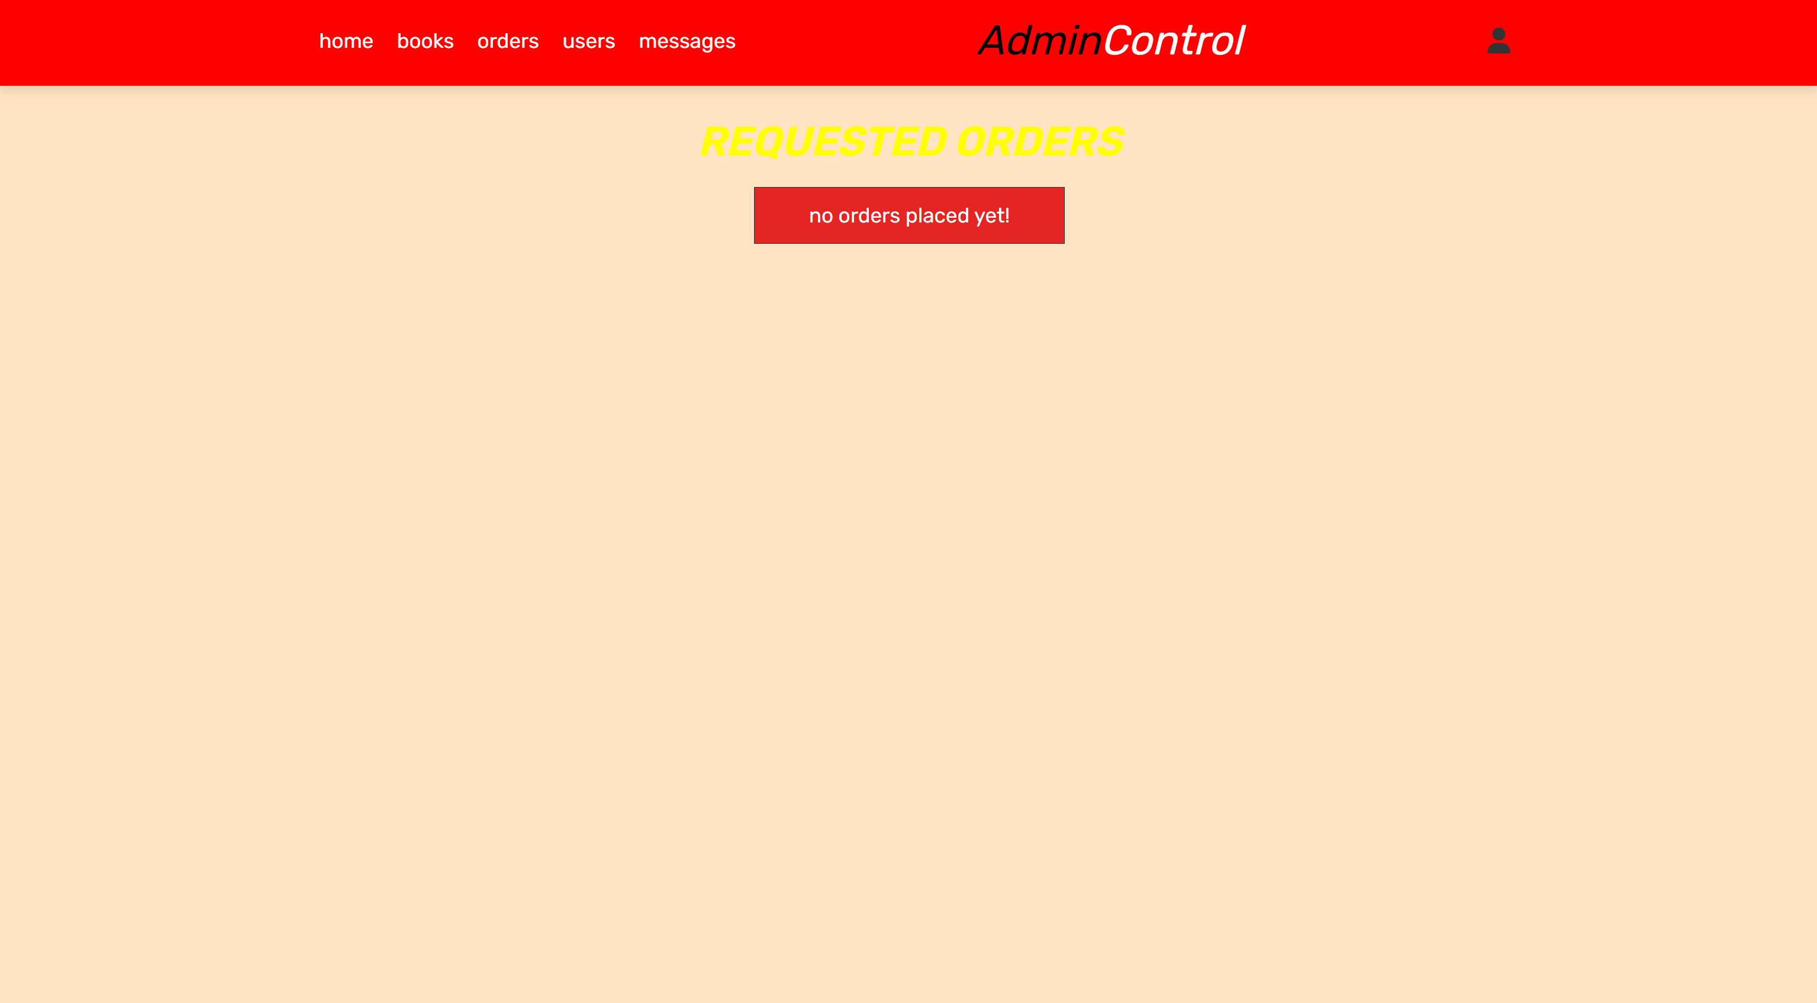

If we have orders it will look like this.

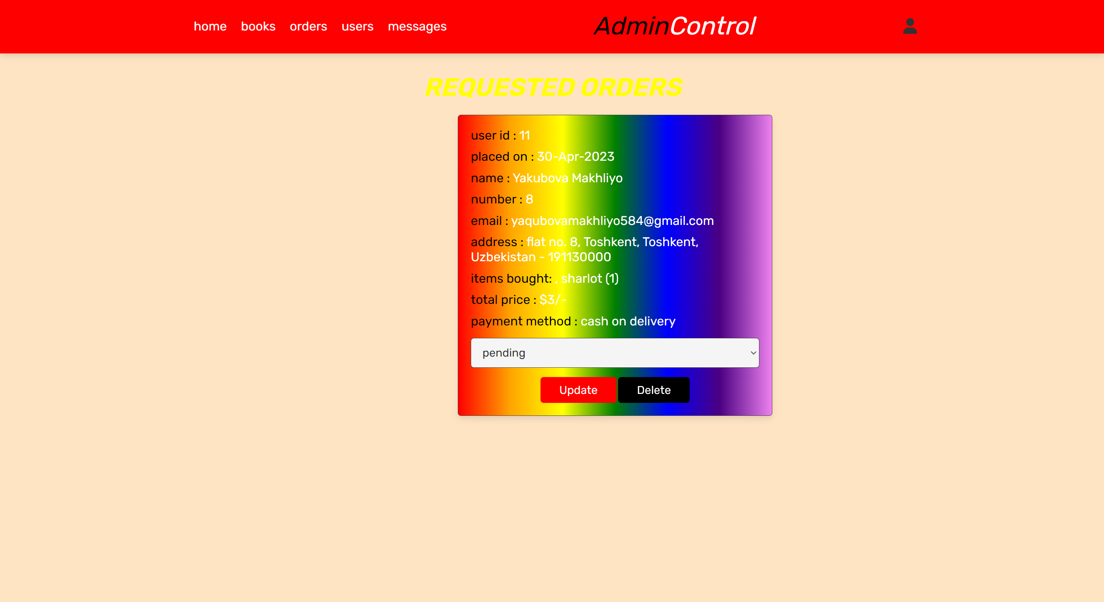

Users page

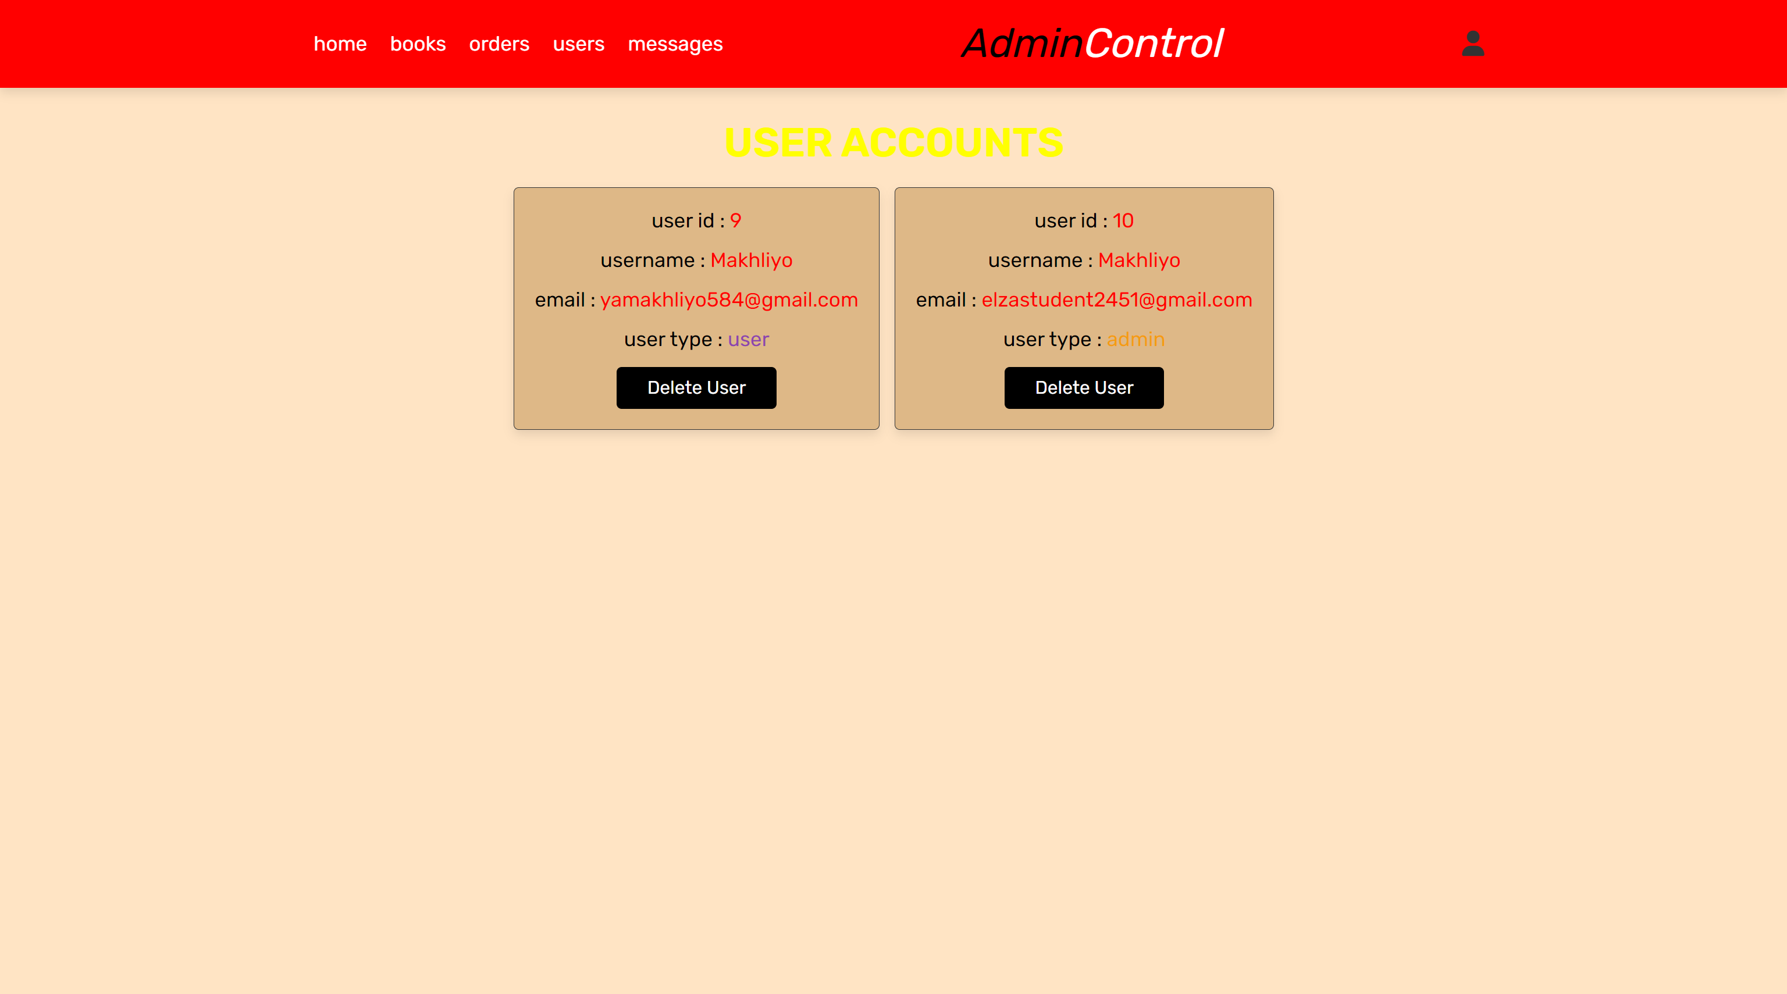

In this page admin can see how many admins or users have.

Messages page

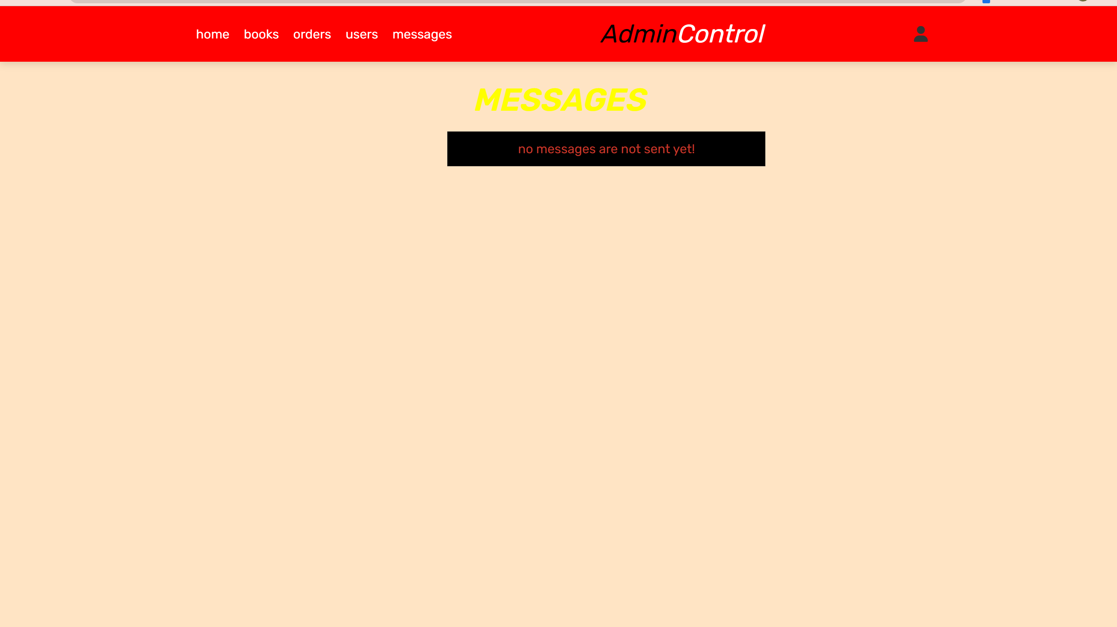

If admin has messages from users , it will look like this.

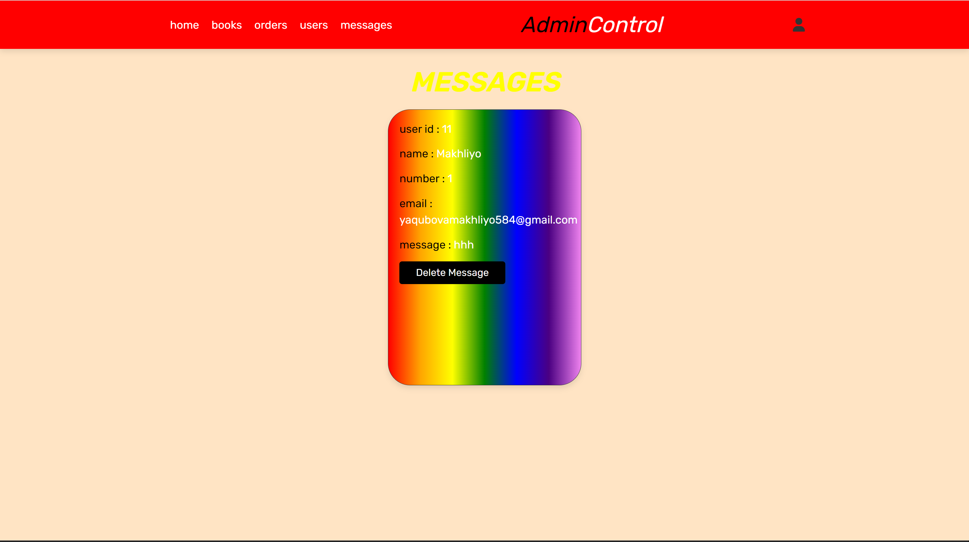

In this page admin can see message sent by users.

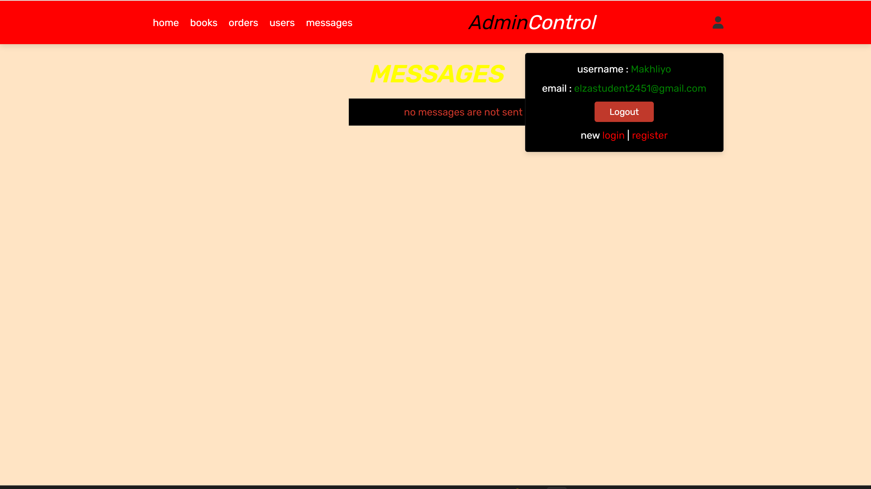

When we click account . It will show admin’s username and email.

Users site

Home page

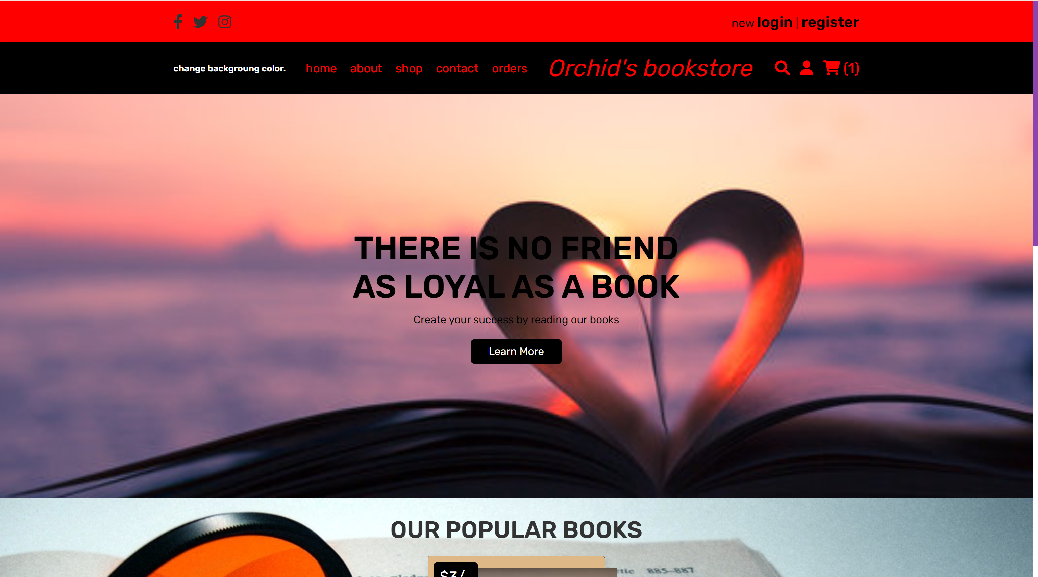



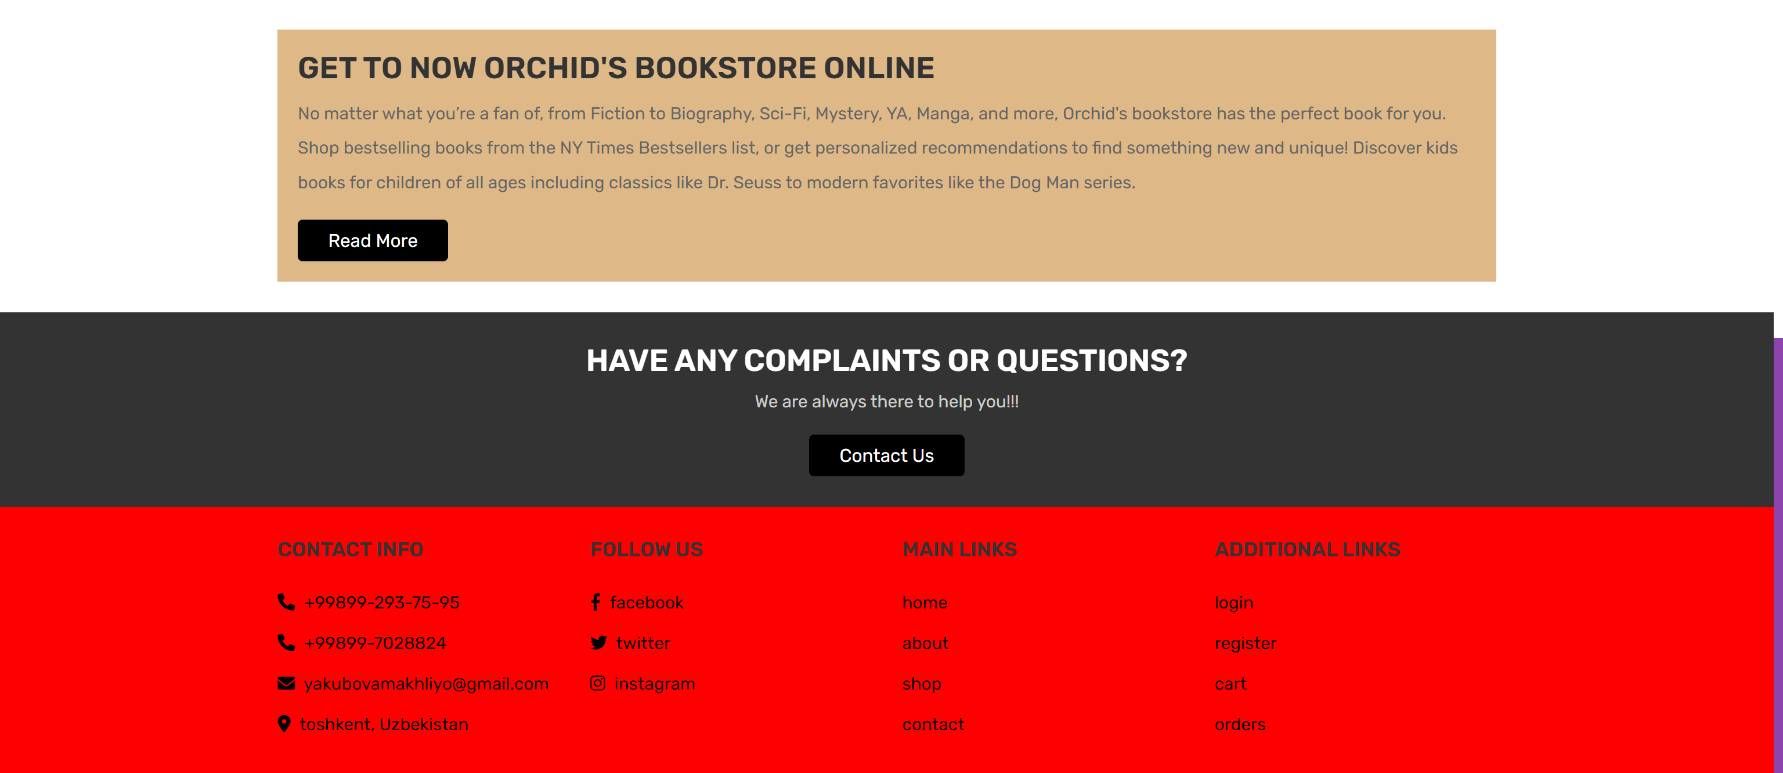

About page

 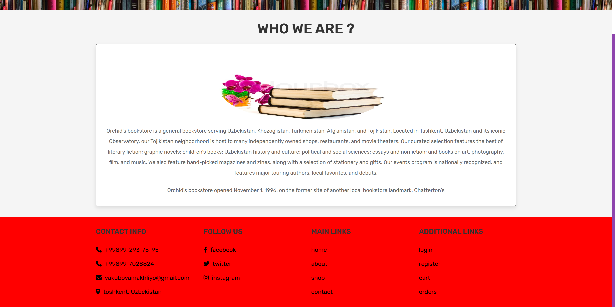

Shop page

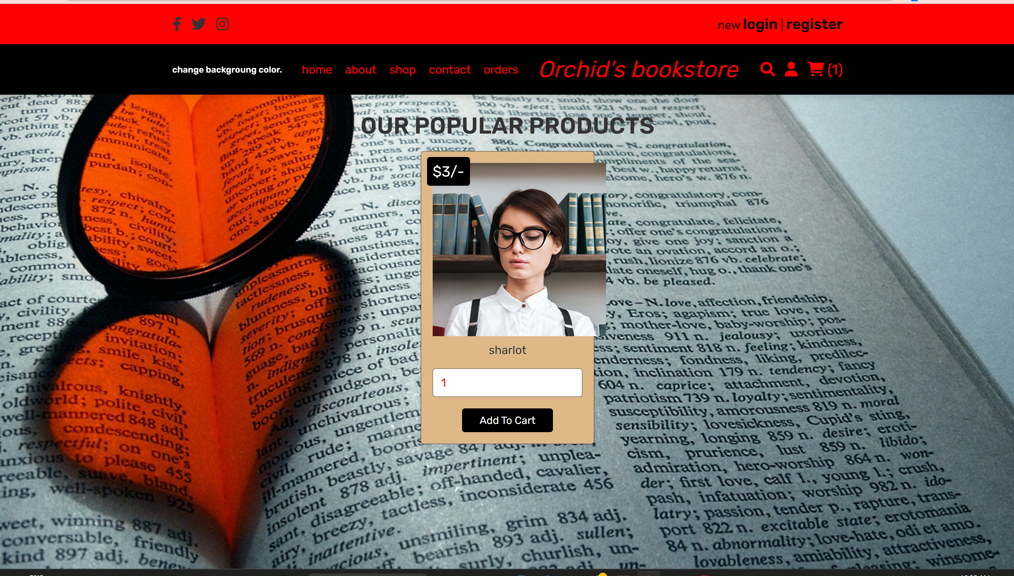

Contacts page

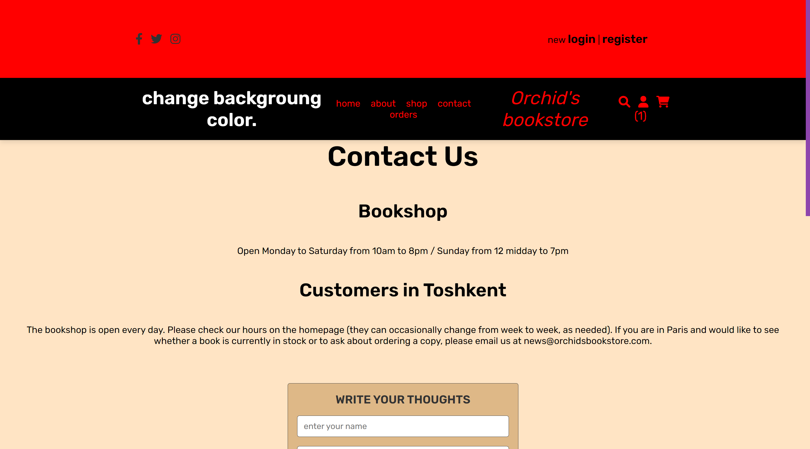

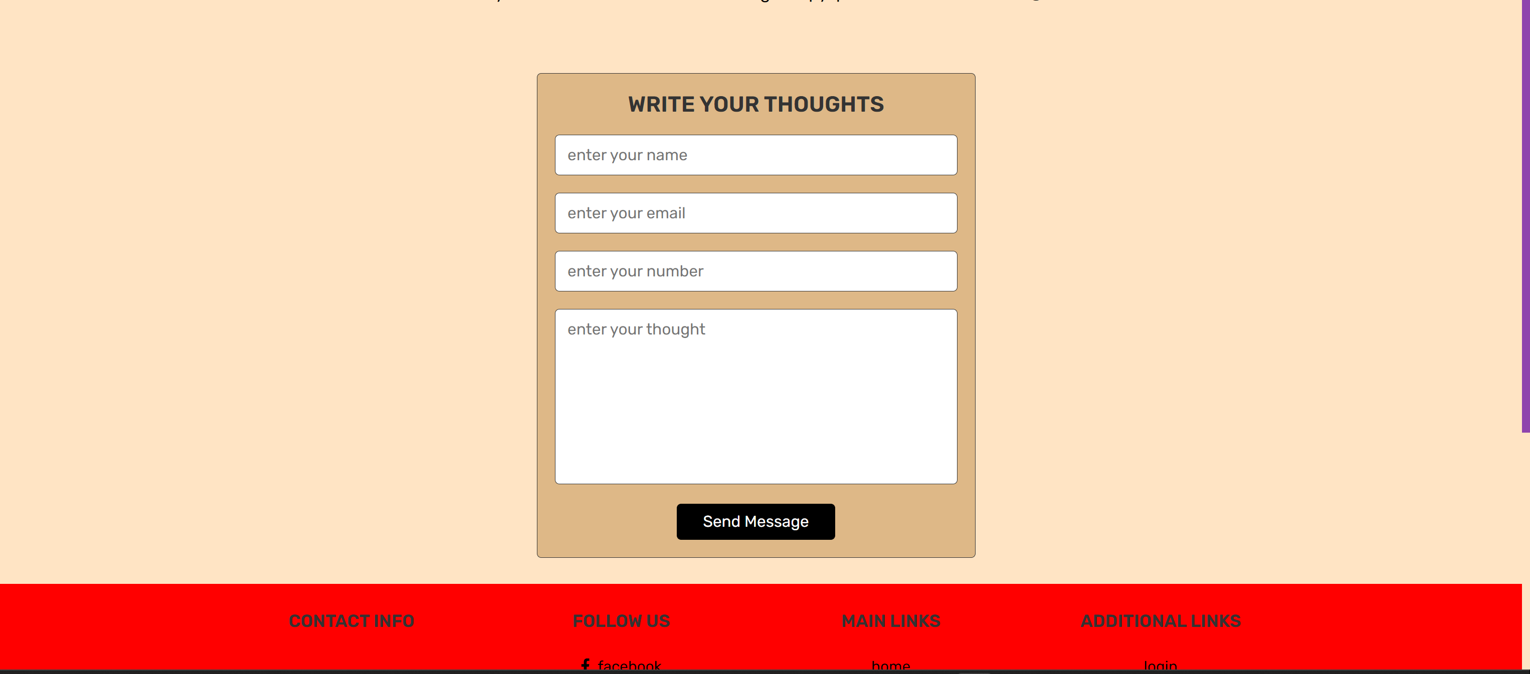

If user can write message to admin.

Order’s page

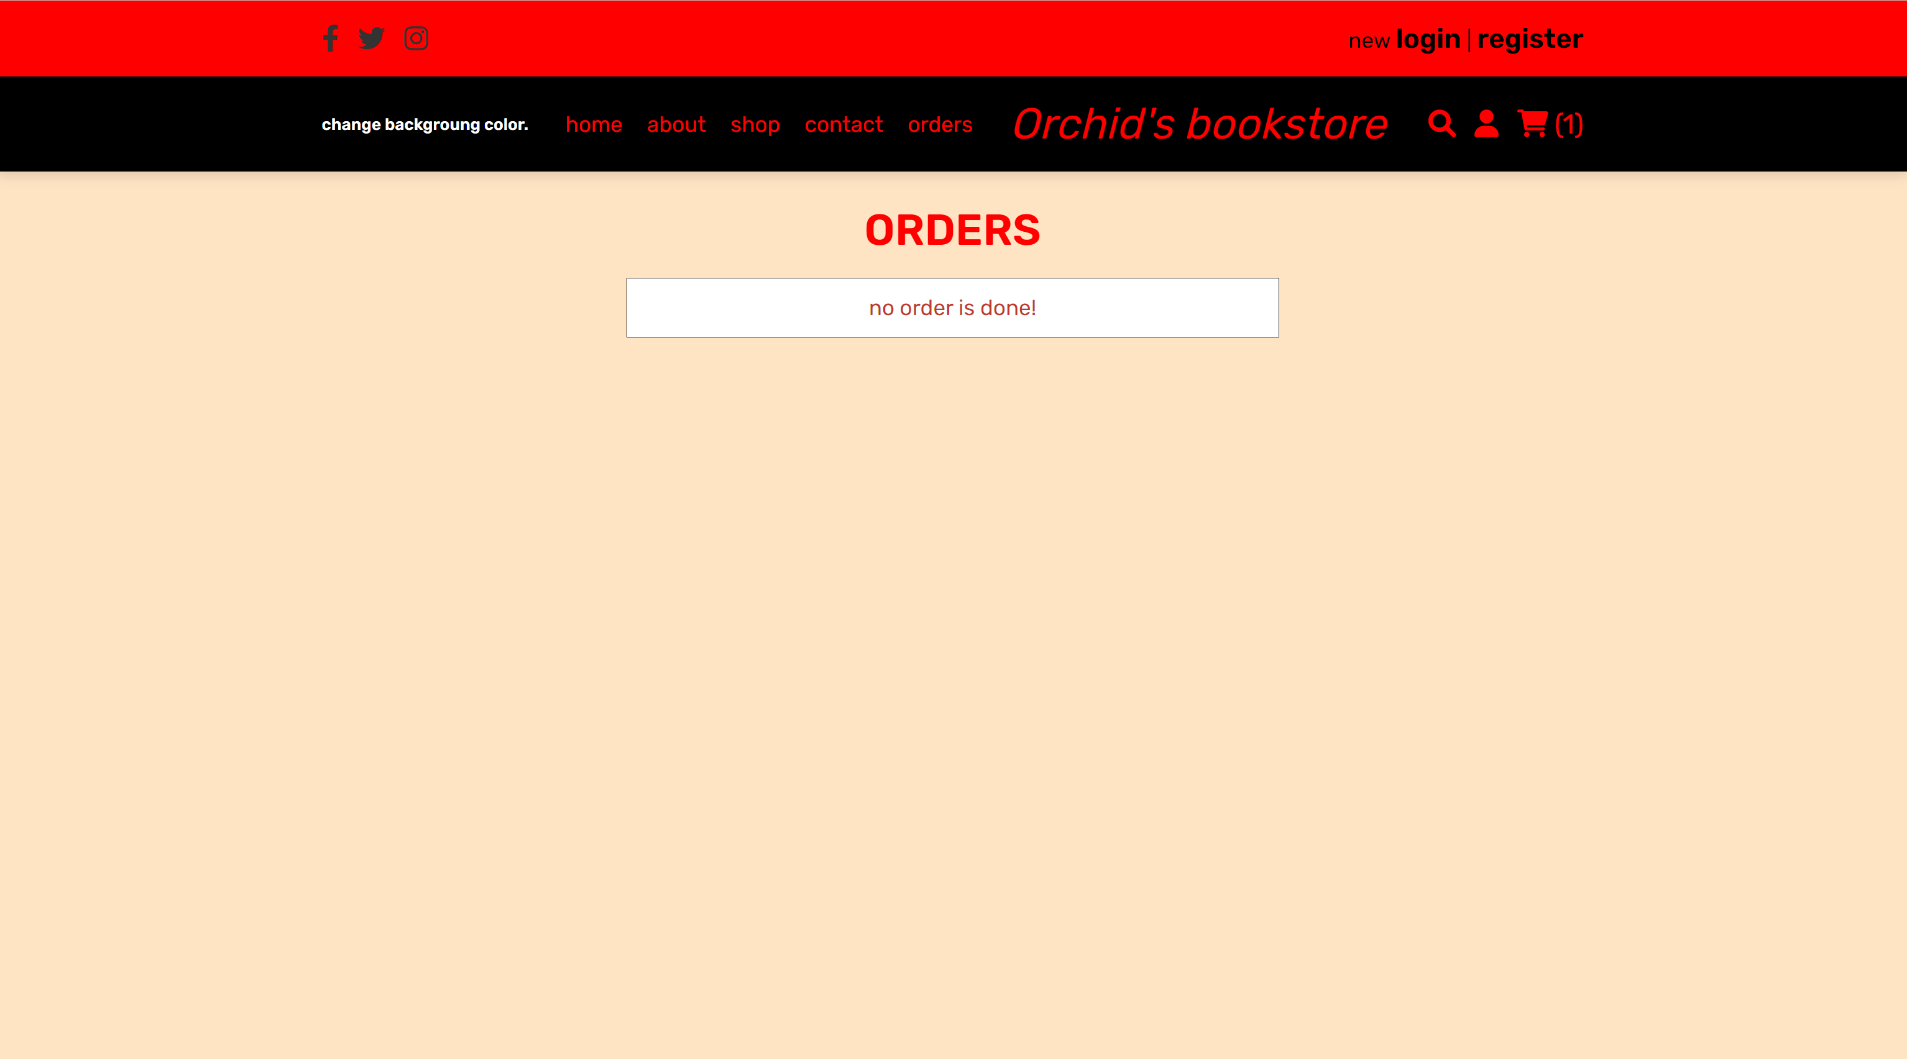

Search page

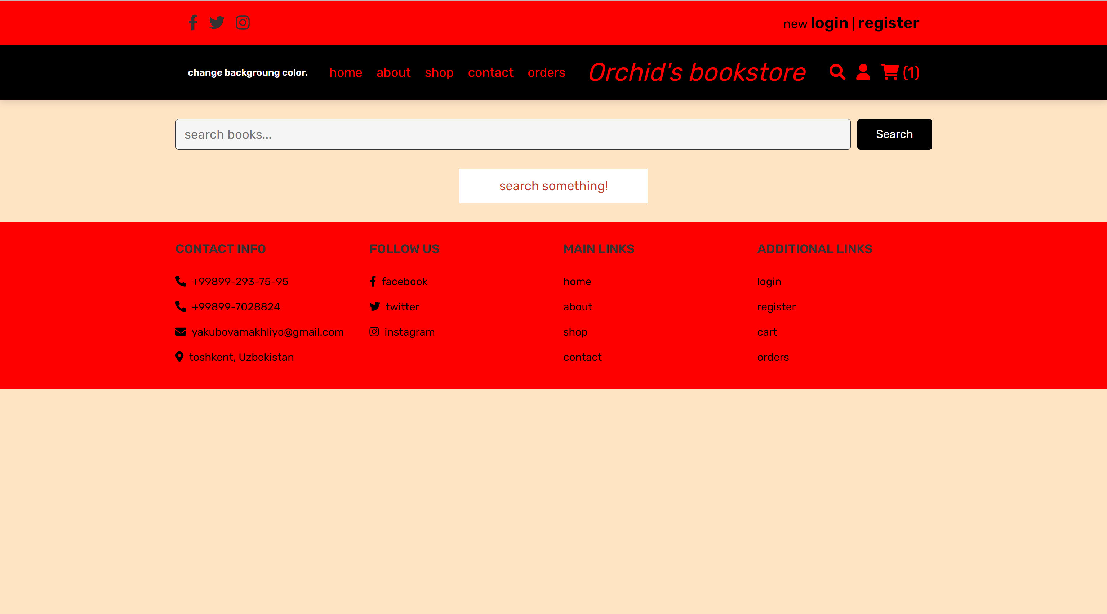

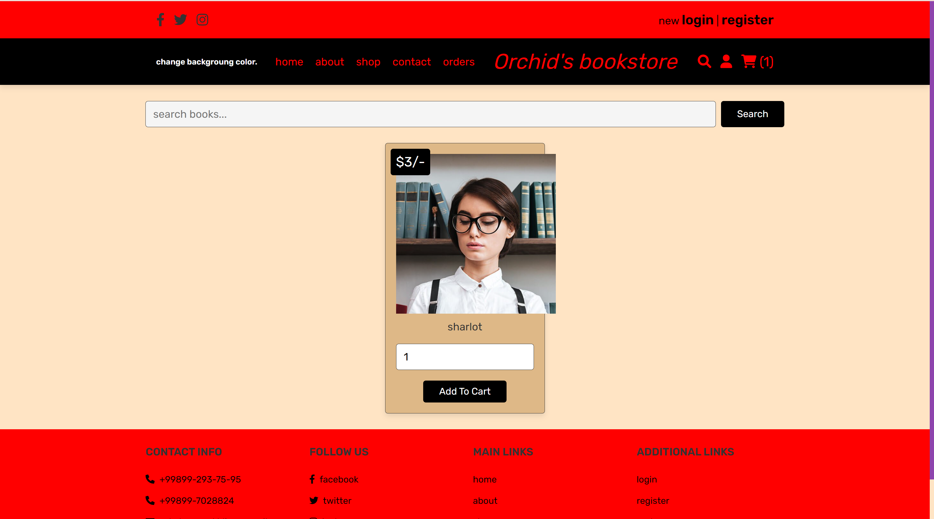

Cart page

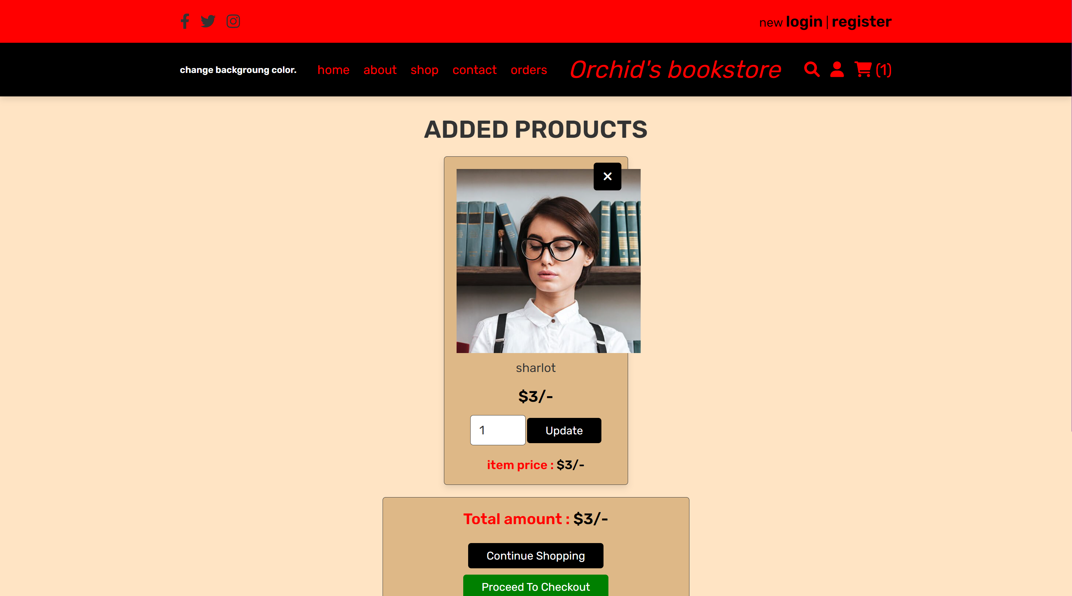

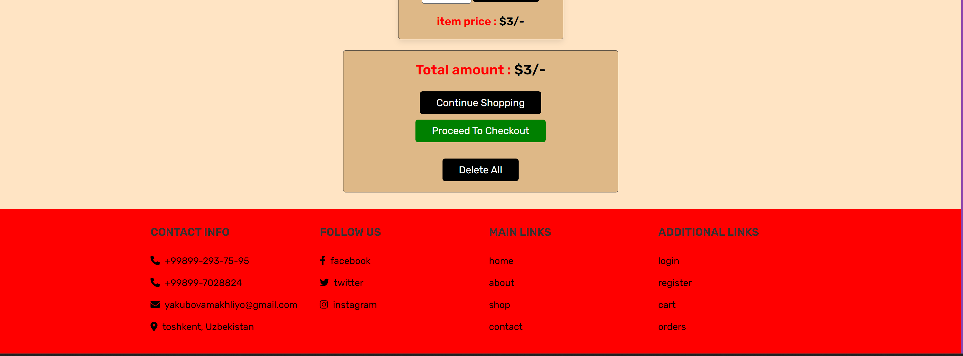

Checkout page

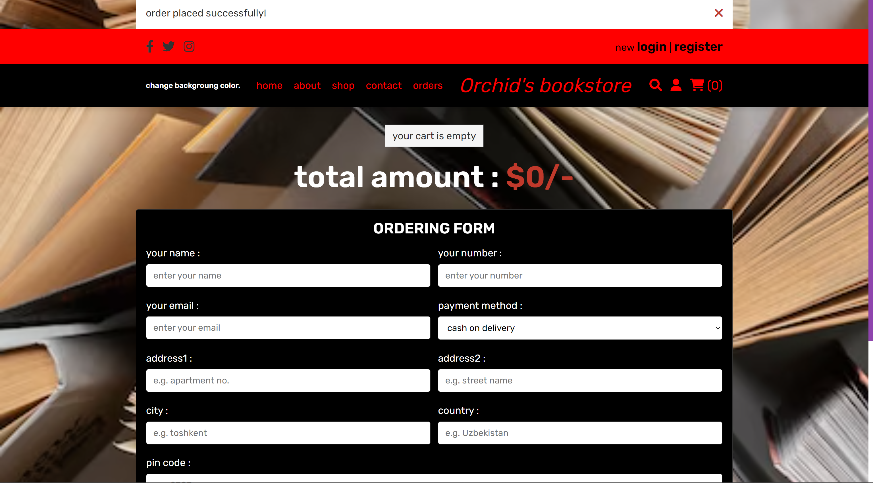

When users click account .It will show.

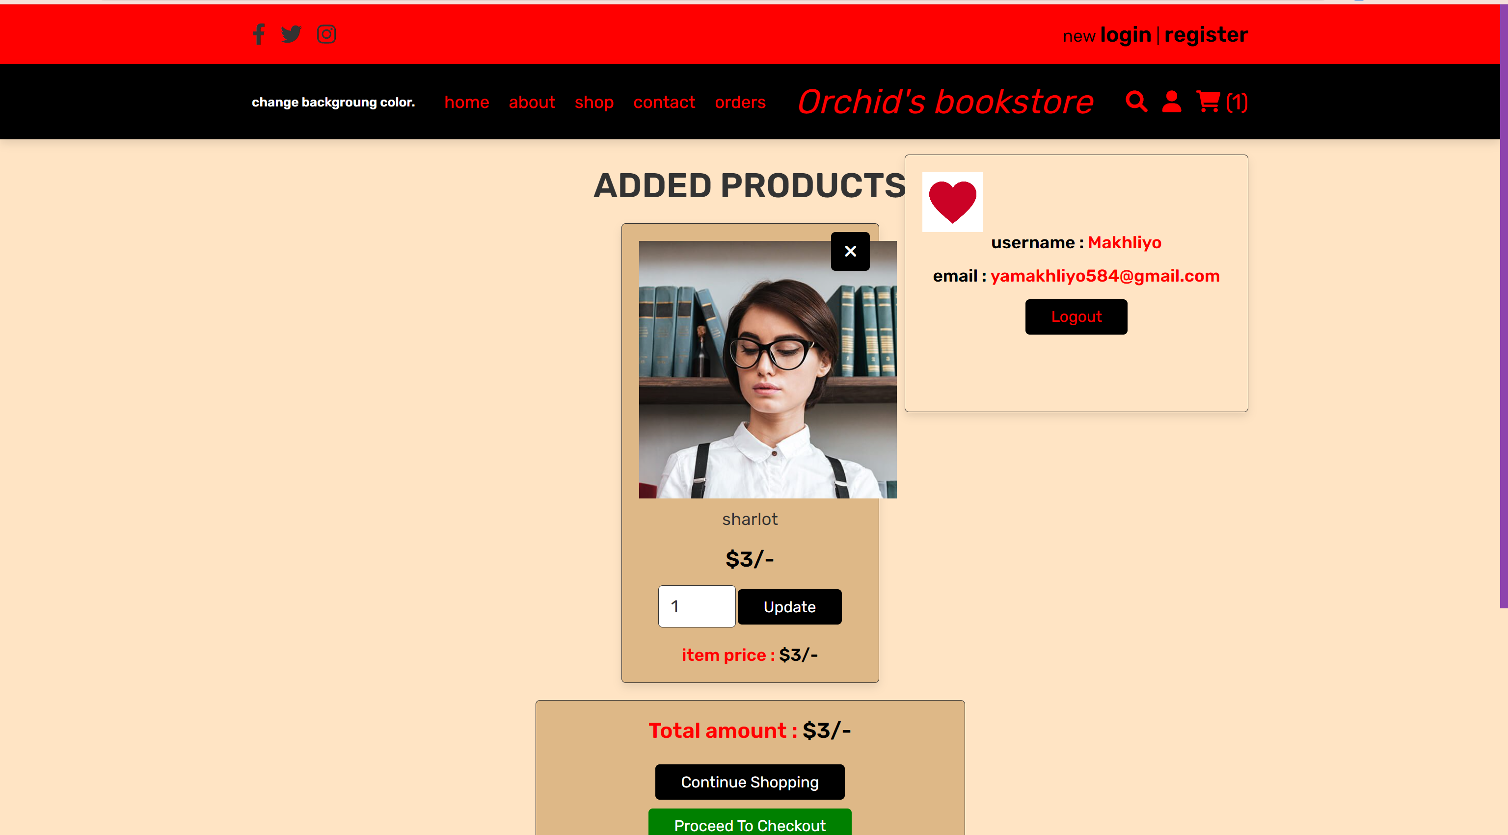

Codes

Css folder

about.css

#about-head{

    background-size: cover;

    background-repeat: no-repeat;

    background-image: url("../images/books-1204029__480.jpg");

}

#orchid{

    width: 500px;

    height: 200px;

}

carts.css

#cart-body {

  background-color: bisque;

}

#brown {

  background-color: burlywood;

}

#black {

  background-color: black;

}

#red {

  background-color: red;

}

#green {

  background-color: green;

}

#c-black {

  color: black;

  font-weight: bold;

}

#c-red {

    color: red;

    font-weight: bold;

}

#total-amount{

    width: 500px;

    background-color: burlywood;

}

checkout.css

#d-order{

    background-image: url("../images/top-view-books-arrangement_23-2148882754.avif");

    background-repeat: no-repeat;

    background-size: cover;

}

#check{

   color: white;

}

#check-form{

    background: black;

}

#check-form h3{

    color: white;

}

#check-form span{

    color: white;

}

#g-total{

   color: white;

    font-weight: bolder;

    font-size: 60px;

}

contacts.css

#contact-color{

    background-color: bisque;

    text-align: center;

}

#c-form{

    background-color: burlywood;

}

#img{

    height: 500px;

    width: 300px;

/* background-image: url("../images/download\ \(1\).jpg"); */

background-repeat: no-repeat;

background-size: cover;

}

#contact-color h1{

    font-size: 60px;

    margin-bottom: 60px;

}

#contact-color h2{

    font-size: 40px;

}

#contact-color p{

    margin: 50px;

    font-size: 20px;

}

footer.css

/* footer */

#foot {

    background-color: red;

  }

  #icon {

    color: black;

  }

  #name {

    color: red;

  }

nav.css

#nav{

    background-color: red;

}

#black{

    background-color: black;

}

#black-color{

    color: black;

    font-weight: 900;

}

#black a{

    color: red;

}

#user-btn{

    color:red;

}

#flexx{

    display: flex;

    align-items: center;

    justify-content: space-between;

}

#l-href{

    font-style: italic;

    font-size: 40px;

}

#qora{

    color: black;

    font-weight: bold;

    font-size: 25px;

}

#style{

    color: black;

}

/* user account */

#user-b{

    height: 300px;width: 400px;

    background-color:bisque;

}

#user-img{

    width: 70px;

    height: 70px;

    background-image: url("../images/istockphoto-1128400054-612x612.jpg");

    background-repeat: no-repeat;

    background-size: cover;

}

#log-out{

    background-color: black;

    color: white;

}

#c-red{

    color: red;

}

orderlist.css

#order-img{

    width: 600px;

    height: 600px;

    background-repeat: no-repeat;

    background-size: cover;

   background-image: url("../images/girl.jpg");

}

#order-l{

    background-color: bisque;

}

#order-box{

    width: 600px;

    background-color: black;

}

#no-order{

   color:rgb(red, green, rgb(41, 41, 124));

}

#box-con{

    display: flex;

    flex-direction: row;

    width: 600px;

}

#or-h1{

    color: red;

}

#oq{

    color: aliceblue;

}

#yellow{

    color: yellow;

}

searches.css

#search-head {

  background-size: cover;

  background-repeat: no-repeat;

  background-image: url("../images/top-view-books-arrangement_23-2148882754.avif");

}

#search-body {

  background-color: bisque;

}

#search-form {

  background-color: burlywood;

}

shop.css

#red{

    color: red;

}

#box-color{

    background-color: burlywood;

}

st-second.css

#form-con {

  background-size: cover;

  background-repeat: no-repeat;

  background-image: url("../images/bookstore-hero-image.jpg.optimal\ -\ Copy\ -\ Copy\ \(2\).jpg");

}

#form-wrap {

  width: 700px;

  background-color: burlywood;

}

#btn-reg {

  background-color: black;

}

* {

  font-family: "Times New Roman", Times, serif;

}

#login-con {

  background-size: cover;

  background-repeat: no-repeat;

  background-image: url("../images/bookstore-hero-image.jpg.optimal\ -\ Copy\ -\ Copy\ \(2\).jpg");

  opacity: 0.7;

}

#reg-color {

  color: red;

}

/* admin control */

#admin-message {

  font-weight: 900;

  color: black;

}

#sec-message {

  background-image: url("../images/bookstore-hero-image.jpg.optimal\ -\ Copy\ -\ Copy\ \(2\).jpg");

  opacity: 0.7;

  background-size: cover;

}

#box-con {

  background-color: black;

}

/* home page */

#home-page {

  background-repeat: no-repeat;

  background-size: cover;

  background-image: url("../images/360_F_144292777_ae60RH6idxDxQLYnIuNXpsD6LGvrArxb.jpg");

}

#context h3 {

  color: black;

}

#context p {

  color: black;

}

#black {

  background-color: black;

}

#brown {

  background-size: cover;

  background-repeat: no-repeat;

  background-image: url("../images/mqSg2I.jpg");

}

#products-img {

  width: 100%;

}

#card {

  background: burlywood;

}

#box-con {

  display: flex;

  align-items: center;

  justify-content: space-around;

  gap: 50px;

}

/* loader */

#loader {

    display: flex;

    align-items: center;

  position: absolute;

  top: 0;

  left: 0;

  width: 100%;

  height: 100vh;

  background-color: black;

  z-index: 99;

}

.myName span :nth-child(1) {

  animation-delay: 4s;

}

.myName span :nth-child(2) {

  animation-delay: 5s;

}

.myName span :nth-child(3) {

  animation-delay: 6s;

}

.myName1 span :nth-child(4) {

  animation-delay: 7s;

}

.myName span :nth-child(5) {

  animation-delay: 8s;

}

.myName span :nth-child(6) {

  animation-delay: 9s;

}

.myName span :nth-child(7) {

  animation-delay: 10s;

}

.myName span :nth-child(8) {

  animation-delay: 11s;

}

video {

  object-fit: cover;

  filter: hue-rotate(100%);

}

.myName {

  margin: 0;

  padding: 0;

  position: absolute;

  top: 50%;

  transform: translateY(-50%);

  width: 100%;

  text-align: center;

  color: #ddd;

  font-size: 5em;

  font-family: sans-serif;

  letter-spacing: 0.2em;

}

.myName span {

  display: inline-block;

  opacity: 0;

  animation: animate 7s linear infinite forwards !important;

}

#white {

  color: white;

  font-size: 80px;

  background-color: blue;

}

style.css

/* global styles for users */

:root {

  --black: #333;

  --white: #fff;

  --light-color: #666;

  --border: 0.1rem solid var(--black);

  --box-shadow: 0 0.5rem 1rem rgba(0, 0, 0, 0.1);

}

* {

  margin: 0;

  padding: 0;

  box-sizing: border-box;

  outline: none;

  border: none;

  text-decoration: none;

  transition: all 0.2s linear;

}

*::selection {

  color: var(--white);

}

*::-webkit-scrollbar {

  height: 0.5rem;

  width: 1rem;

}

*::-webkit-scrollbar-track {

  background-color: transparent;

}

html {

  font-size: 62.5%;

  overflow-x: hidden;

}

section {

  padding: 3rem 2rem;

}

.empty {

  padding: 1.5rem;

  text-align: center;

  border: var(--border);

  background-color: var(--white);

  color: var(--red);

  font-size: 2rem;

}

.message {

  position: sticky;

  top: 0;

  margin: 0 auto;

  max-width: 1200px;

  background-color: var(--white);

  padding: 2rem;

  display: flex;

  align-items: center;

  justify-content: space-between;

  z-index: 10000;

  gap: 1.5rem;

}

.message span {

  font-size: 2rem;

  color: var(--black);

}

.message i {

  cursor: pointer;

  color: var(--red);

  font-size: 2.5rem;

}

.message i:hover {

  transform: rotate(90deg);

}

.title {

  text-align: center;

  margin-bottom: 2rem;

  text-transform: uppercase;

  color: var(--black);

  font-size: 4rem;

}

.btn,

.option-btn,

.delete-btn,

.white-btn {

  display: inline-block;

  margin-top: 1rem;

  padding: 1rem 3rem;

  cursor: pointer;

  color: var(--white);

  font-size: 1.8rem;

  border-radius: 0.5rem;

  text-transform: capitalize;

}

.btn:hover,

.option-btn:hover,

.delete-btn:hover {

  background-color: var(--black);

}

.delete-btn {

  background-color: var(--red);

}

.white-btn:hover {

  color: var(--black);

}

/* header */

.heading {

  min-height: 50vh;

  display: flex;

  flex-flow: column;

  align-items: center;

  justify-content: center;

  gap: 1rem;

  background-size: cover;

  background-position: center;

  text-align: center;

}

.heading h3 {

  font-size: 5rem;

  color: var(--black);

  text-transform: uppercase;

}

.heading p {

  font-size: 2.5rem;

  color: var(--light-color);

}

.heading p a:hover {

  text-decoration: underline;

}

@keyframes fadeIn {

  0% {

    transform: translateY(1rem);

    opacity: 0.2s;

  }

}

.form-container {

  min-height: 100vh;

  display: flex;

  align-items: center;

  justify-content: center;

  padding: 2rem;

}

.form-container form {

  padding: 2rem;

  width: 50rem;

  border-radius: 0.5rem;

  border: var(--border);

  text-align: center;

}

.form-container form h3 {

  font-size: 3rem;

  margin-bottom: 1rem;

  text-transform: uppercase;

  color: var(--black);

}

.form-container form .box {

  width: 100%;

  border-radius: 0.5rem;

  padding: 1.2rem 1.4rem;

  font-size: 1.8rem;

  color: var(--black);

  border: var(--border);

  margin: 1rem 0;

}

.form-container form p {

  padding-top: 1.5rem;

  font-size: 2rem;

  color: var(--black);

}

.form-container form p a {

  color: var(--purple);

}

.form-container form p a:hover {

  text-decoration: underline;

}

.header .header-1 .flex {

  padding: 2rem;

  display: flex;

  align-items: center;

  justify-content: space-between;

  max-width: 1200px;

  margin: 0 auto;

}

.header .header-2.active {

  position: fixed;

  top: 0;

  left: 0;

  right: 0;

  z-index: 1000;

}

.header .header-2 .flex {

  padding: 2rem;

  display: flex;

  align-items: center;

  justify-content: space-between;

  max-width: 1200px;

  margin: 0 auto;

  position: relative;

}

.header .header-1 .flex .share a {

  font-size: 2.5rem;

  margin-right: 1.5rem;

  color: var(--black);

}

.header .header-1 .flex p {

  font-size: 2rem;

}

.header .header-1 .flex p a:hover {

  text-decoration: underline;

}

.header .header-2 .flex .logo {

  font-size: 2.5rem;

}

.header .header-2 .flex .navbar a {

  margin: 0 1rem;

  font-size: 2rem;

}

.header .header-2 .flex .navbar a:hover {

  text-decoration: underline;

}

.header .header-2 .flex .icons > * {

  font-size: 2.5rem;

  color: var(--black);

  cursor: pointer;

  margin-left: 1.5rem;

}

#menu-btn {

  display: none;

}

.header .header-2 .flex .user-box {

  position: absolute;

  top: 120%;

  right: 2rem;

  border-radius: 0.5rem;

  box-shadow: var(--box-shadow);

  border: var(--border);

  padding: 2rem;

  text-align: center;

  width: 30rem;

  display: none;

  animation: fadeIn 0.2s linear;

}

.header .header-2 .flex .user-box.active {

  display: inline-block;

}

.header .header-2 .flex .user-box p {

  font-size: 2rem;

  color: var(--light-color);

  margin-bottom: 1.5rem;

}

.header .header-2 .flex .user-box .delete-btn {

  margin-top: 0;

}

.home {

  min-height: 70vh;

  background-position: center;

  display: flex;

  align-items: center;

  justify-content: center;

}

.home .content {

  text-align: center;

  width: 60rem;

}

.home .content h3 {

  font-size: 5.5rem;

  color: var(--white);

  text-transform: uppercase;

}

.home .content p {

  font-size: 1.8rem;

  padding: 1rem 0;

  line-height: 1.5;

}

/* products page */

.products .box-container {

  max-width: 1200px;

  margin: 0 auto;

  display: grid;

  grid-template-columns: repeat(auto-fit, 30rem);

  align-items: flex-start;

  gap: 1.5rem;

  justify-content: center;

}

.products .box-container .box {

  border-radius: 0.5rem;

  box-shadow: var(--box-shadow);

  padding: 2rem;

  text-align: center;

  border: var(--border);

  position: relative;

}

.products .box-container .box .image {

  height: 30rem;

}

.products .box-container .box .name {

  padding: 1rem 0;

  font-size: 2rem;

  color: var(--black);

}

.products .box-container .box .qty {

  width: 100%;

  padding: 1.2rem 1.4rem;

  border-radius: 0.5rem;

  border: var(--border);

  margin: 1rem 0;

  font-size: 2rem;

}

.products .box-container .box .price {

  position: absolute;

  top: 1rem;

  left: 1rem;

  border-radius: 0.5rem;

  padding: 1rem;

  font-size: 2.5rem;

  color: var(--white);

}

.about .flex {

  max-width: 1200px;

  margin: 0 auto;

  display: flex;

  align-items: center;

  flex-wrap: wrap;

}

/* about page */

.about .flex .image {

  flex: 1 1 40rem;

}

.about .flex .image img {

  width: 100%;

}

.about .flex .content {

  flex: 1 1 40rem;

  padding: 2rem;

}

#red {

  color: #c0392b;

}

.about .flex .content h3 {

  font-size: 3rem;

  color: var(--black);

  text-transform: uppercase;

}

.about .flex .content p {

  padding: 1rem 0;

  line-height: 2;

  font-size: 1.7rem;

}

.home-contact .content {

  max-width: 60rem;

  text-align: center;

  margin: 0 auto;

}

.home-contact .content h3 {

  font-size: 3rem;

  text-transform: uppercase;

  color: var(--white);

}

.home-contact .content p {

  padding: 1rem 0;

  line-height: 1.5;

  color: var(--light-white);

  font-size: 1.7rem;

}

.reviews .box-container {

  max-width: 1200px;

  margin: 0 auto;

  display: grid;

  grid-template-columns: repeat(auto-fit, minmax(30rem, 1fr));

  align-items: center;

  gap: 1.5rem;

  justify-content: center;

}

.reviews .box-container .box {

  background-color: var(--white);

  box-shadow: var(--box-shadow);

  border: var(--border);

  border-radius: 0.5rem;

  text-align: center;

  padding: 2rem;

}

.reviews .box-container .box img {

  height: 10rem;

  width: 10rem;

  border-radius: 50%;

}

.reviews .box-container .box p {

  padding: 1rem 0;

  line-height: 2;

  font-size: 1.5rem;

}

.reviews .box-container .box .stars {

  background-color: var(--light-bg);

  display: inline-block;

  margin: 0.5rem 0;

  border-radius: 0.5rem;

  border: var(--border);

  padding: 0.5rem 1.5rem;

}

.reviews .box-container .box .stars i {

  font-size: 1.7rem;

  margin: 0.2rem;

}

.contact form {

  margin: 0 auto;

  border-radius: 0.5rem;

  border: var(--border);

  padding: 2rem;

  max-width: 50rem;

  margin: 0 auto;

  text-align: center;

}

.contact form h3 {

  font-size: 2.5rem;

  text-transform: uppercase;

  margin-bottom: 1rem;

  color: var(--black);

}

.contact form .box {

  margin: 1rem 0;

  width: 100%;

  border: var(--border);

  padding: 1.2rem 1.4rem;

  font-size: 1.8rem;

  color: var(--black);

  border-radius: 0.5rem;

}

.contact form textarea {

  height: 20rem;

  resize: none;

}

/* shopping cart */

.shopping-cart .box-container {

  max-width: 1200px;

  margin: 0 auto;

  display: grid;

  grid-template-columns: repeat(auto-fit, 30rem);

  align-items: center;

  gap: 1.5rem;

  justify-content: center;

}

.shopping-cart .box-container .box {

  text-align: center;

  padding: 2rem;

  border-radius: 0.5rem;

  box-shadow: var(--box-shadow);

  position: relative;

  border: var(--border);

}

.shopping-cart .box-container .box .fa-times {

  position: absolute;

  top: 1rem;

  right: 1rem;

  height: 4.5rem;

  width: 4.5rem;

  line-height: 4.5rem;

  font-size: 2rem;

  color: var(--white);

  border-radius: 0.5rem;

}

.shopping-cart .box-container .box .fa-times:hover {

  background-color: var(--black);

}

.shopping-cart .box-container .box img {

  height: 30rem;

}

.shopping-cart .box-container .box .name {

  padding: 1rem 0;

  font-size: 2rem;

  color: var(--black);

}

.shopping-cart .box-container .box .price {

  padding: 1rem 0;

  font-size: 2.5rem;

  color: var(--red);

}

.shopping-cart .box-container .box input[type="number"] {

  margin: 0.5rem 0;

  border: var(--border);

  border-radius: 0.5rem;

  padding: 1.2rem 1.4rem;

  font-size: 2rem;

  color: var(--black);

  width: 9rem;

}

.shopping-cart .box-container .box .sub-total {

  padding-top: 1.5rem;

  font-size: 2rem;

  color: var(--light-color);

}

.shopping-cart .box-container .box .sub-total span {

  color: var(--red);

}

.shopping-cart .cart-total {

  max-width: 1200px;

  margin: 0 auto;

  border: var(--border);

  padding: 2rem;

  text-align: center;

  margin-top: 2rem;

  border-radius: 0.5rem;

}

.shopping-cart .cart-total p {

  font-size: 2.5rem;

  color: var(--light-color);

}

.shopping-cart .cart-total .flex {

  display: flex;

  flex-wrap: wrap;

  column-gap: 1rem;

  margin-top: 1.5rem;

  justify-content: center;

}

.shopping-cart .disabled {

  pointer-events: none;

  opacity: 0.5;

  user-select: none;

}

.display-order {

  max-width: 1200px;

  margin: 0 auto;

  text-align: center;

  padding-bottom: 0;

}

.display-order p {

  color: var(--black);

  font-size: 2rem;

  padding: 1rem 1.5rem;

  border: var(--border);

  display: inline-block;

  margin: 0.5rem;

}

.display-order .grand-total {

  margin-top: 2rem;

  font-size: 2.5rem;

  color: var(--light-color);

}

.display-order .grand-total span {

  color: var(--red);

}

.checkout form {

  max-width: 1200px;

  padding: 2rem;

  margin: 0 auto;

  border: var(--border);

  border-radius: 0.5rem;

}

.checkout form h3 {

  text-align: center;

  margin-bottom: 2rem;

  color: var(--black);

  text-transform: uppercase;

  font-size: 3rem;

}

.checkout form .flex {

  display: flex;

  flex-wrap: wrap;

  gap: 1.5rem;

}

.checkout form .flex .inputBox {

  flex: 1 1 40rem;

}

.checkout form .flex span {

  font-size: 2rem;

  color: var(--black);

}

.checkout form .flex select,

.checkout form .flex input {

  border: var(--border);

  width: 100%;

  border-radius: 0.5rem;

  width: 100%;

  background-color: var(--white);

  padding: 1.2rem 1.4rem;

  font-size: 1.8rem;

  margin: 1rem 0;

}

.placed-orders .box-container {

  max-width: 1200px;

  margin: 0 auto;

  display: flex;

  flex-wrap: wrap;

  align-items: center;

  gap: 1.5rem;

}

.placed-orders .box-container .empty {

  flex: 1;

}

.placed-orders .box-container .box {

  flex: 1 1 40rem;

  border-radius: 0.5rem;

  padding: 2rem;

  border: var(--border);

  padding: 1rem 2rem;

}

.placed-orders .box-container .box p {

  padding: 1rem 0;

  font-size: 2rem;

}

/* search */

.search-form form {

  max-width: 1200px;

  margin: 0 auto;

  display: flex;

  gap: 1rem;

}

.search-form form .btn {

  margin-top: 0;

}

.search-form form .box {

  width: 100%;

  padding: 1.2rem 1.4rem;

  border: var(--border);

  font-size: 2rem;

  color: var(--black);

  border-radius: 0.5rem;

}

/* footer */

.footer .box-container {

  max-width: 1200px;

  margin: 0 auto;

  display: grid;

  grid-template-columns: repeat(auto-fit, minmax(25rem, 1fr));

  gap: 3rem;

}

.footer .box-container .box h3 {

  text-transform: uppercase;

  color: var(--black);

  font-size: 2rem;

  padding-bottom: 2rem;

}

.footer .box-container .box p,

.footer .box-container .box a {

  display: block;

  font-size: 1.7rem;

  padding: 1rem 0;

}

.footer .box-container .box p i,

.footer .box-container .box a i {

  padding-right: 0.5rem;

}

.footer .box-container .box a:hover {

  text-decoration: underline;

}

.footer .credit {

  text-align: center;

  font-size: 2rem;

  color: var(--light-color);

  border-top: var(--border);

  margin-top: 2.5rem;

  padding-top: 2.5rem;

}

admin_style.css

/* global style */

:root {

  --black: #333;

  --white: #fff;

  --light-color: #666;

  --light-white: #ccc;

  --light-bg: #f5f5f5;

  --border: 0.1rem solid var(--black);

  --box-shadow: 0 0.5rem 1rem rgba(0, 0, 0, 0.1);

}

* {

  font-family: "Rubik", sans-serif;

  margin: 0;

  padding: 0;

  box-sizing: border-box;

  outline: none;

  border: none;

  text-decoration: none;

  transition: all 0.2s linear;

}

*::selection {

  background-color: var(--purple);

  color: var(--white);

}

*::-webkit-scrollbar {

  height: 0.5rem;

  width: 1rem;

}

*::-webkit-scrollbar-track {

  background-color: transparent;

}

*::-webkit-scrollbar-thumb {

  background-color: var(--purple);

}

html {

  font-size: 62.5%;

  overflow-x: hidden;

}

body {

  background-color: var(--light-bg);

}

section {

  padding: 3rem 2rem;

}

.title {

  text-align: center;

  margin-bottom: 2rem;

  text-transform: uppercase;

  color: var(--black);

  font-size: 4rem;

}

.empty {

  padding: 1.5rem;

  text-align: center;

  border: var(--border);

  background-color: var(--white);

  color: var(--red);

  font-size: 2rem;

}

 /* section messege */

.message {

  position: sticky;

  top: 0;

  margin: 0 auto;

  max-width: 1200px;

  background-color: var(--light-bg);

  padding: 2rem;

  display: flex;

  align-items: center;

  justify-content: space-between;

  z-index: 10000;

  gap: 1.5rem;

}

.message span {

  font-size: 2rem;

  color: var(--black);

}

.message i {

  cursor: pointer;

  color: var(--red);

  font-size: 2.5rem;

}

.message i:hover {

  transform: rotate(90deg);

}

.btn,

.option-btn,

.delete-btn,

.white-btn {

  display: inline-block;

  margin-top: 1rem;

  padding: 1rem 3rem;

  cursor: pointer;

  color: var(--white);

  font-size: 1.8rem;

  border-radius: 0.5rem;

  text-transform: capitalize;

}

.btn:hover,

.option-btn:hover,

.delete-btn:hover {

  background-color: var(--black);

}

.white-btn,

.btn {

  background-color: var(--purple);

}

.option-btn {

  background-color: var(--orange);

}

.delete-btn {

  background-color: var(--red);

}

.white-btn:hover {

  background-color: var(--white);

  color: var(--black);

}

@keyframes fadeIn {

  0% {

    transform: translateY(1rem);

    opacity: 0.2s;

  }

}

 /* admin header */

.header {

  position: sticky;

  top: 0;

  left: 0;

  right: 0;

  z-index: 1000;

  background-color: var(--white);

  box-shadow: var(--box-shadow);

}

.header .flex {

  display: flex;

  align-items: center;

  padding: 2rem;

  justify-content: space-between;

  position: relative;

  max-width: 1200px;

  margin: 0 auto;

}

.header .flex .logo {

  font-size: 2.5rem;

  color: var(--black);

}

.header .flex .logo span {

  color: var(--purple);

}

.header .flex .navbar a {

  margin: 0 1rem;

  font-size: 2rem;

  color: var(--black);

}

.header .flex .navbar a:hover {

  color: var(--purple);

}

.header .flex .icons div {

  margin-left: 1.5rem;

  font-size: 2.5rem;

  cursor: pointer;

  color: var(--black);

}

.header .flex .icons div:hover {

  color: var(--purple);

}

.header .flex .account-box {

  position: absolute;

  top: 120%;

  right: 2rem;

  width: 30rem;

  box-shadow: var(--box-shadow);

  border-radius: 0.5rem;

  padding: 2rem;

  text-align: center;

  border-radius: 0.5rem;

  border: var(--border);

  background-color: var(--white);

  display: none;

  animation: fadeIn 0.2s linear;

}

.header .flex .account-box.active {

  display: inline-block;

}

.header .flex .account-box p {

  font-size: 2rem;

  color: var(--light-color);

  margin-bottom: 1.5rem;

}

.header .flex .account-box p span {

  color: var(--purple);

}

.header .flex .account-box .delete-btn {

  margin-top: 0;

}

.header .flex .account-box div {

  margin-top: 1.5rem;

  font-size: 2rem;

  color: var(--light-color);

}

.header .flex .account-box div a {

  color: var(--orange);

}

.header .flex .account-box div a:hover {

  text-decoration: underline;

}

#menu-btn {

  display: none;

}

/* admin home */

.dashboard .box-container {

  display: grid;

  grid-template-columns: repeat(auto-fit, minmax(25rem, 1fr));

  gap: 1.5rem;

  max-width: 1200px;

  margin: 0 auto;

  align-items: flex-start;

}

.dashboard .box-container .box {

  border-radius: 0.5rem;

  padding: 2rem;

  background-color: var(--white);

  box-shadow: var(--box-shadow);

  border: var(--border);

  text-align: center;

}

.dashboard .box-container .box h3 {

  font-size: 5rem;

  color: var(--black);

}

.dashboard .box-container .box p {

  margin-top: 1.5rem;

  padding: 1.5rem;

  background-color: var(--light-bg);

  color: var(--purple);

  font-size: 2rem;

  border-radius: 0.5rem;

  border: var(--border);

}

 /* section add products */

.add-products form {

  background-color: var(--white);

  border-radius: 0.5rem;

  padding: 2rem;

  text-align: center;

  box-shadow: var(--box-shadow);

  border: var(--border);

  max-width: 50rem;

  margin: 0 auto;

}

.add-products form h3 {

  font-size: 2.5rem;

  text-transform: uppercase;

  color: var(--black);

  margin-bottom: 1.5rem;

}

.add-products form .box {

  width: 100%;

  background-color: var(--light-bg);

  border-radius: 0.5rem;

  margin: 1rem 0;

  padding: 1.2rem 1.4rem;

  color: var(--black);

  font-size: 1.8rem;

  border: var(--border);

}

.show-products .box-container {

  display: grid;

  grid-template-columns: repeat(auto-fit, 30rem);

  justify-content: center;

  gap: 1.5rem;

  max-width: 1200px;

  margin: 0 auto;

  align-items: flex-start;

}

.show-products {

  padding-top: 0;

}

.show-products .box-container .box {

  text-align: center;

  padding: 2rem;

  border-radius: 0.5rem;

  border: var(--border);

  box-shadow: var(--box-shadow);

  background-color: var(--white);

}

.show-products .box-container .box img {

  height: 30rem;

}

.show-products .box-container .box .name {

  padding: 1rem 0;

  font-size: 2rem;

  color: var(--black);

}

.show-products .box-container .box .price {

  padding: 1rem 0;

  font-size: 2.5rem;

  color: var(--red);

}

.edit-product-form {

  min-height: 100vh;

  background-color: rgba(0, 0, 0, 0.7);

  display: flex;

  align-items: center;

  justify-content: center;

  padding: 2rem;

  overflow-y: scroll;

  position: fixed;

  top: 0;

  left: 0;

  z-index: 1200;

  width: 100%;

}

.edit-product-form form {

  width: 50rem;

  padding: 2rem;

  text-align: center;

  border-radius: 0.5rem;

  background-color: var(--white);

}

.edit-product-form form img {

  height: 25rem;

  margin-bottom: 1rem;

}

.edit-product-form form .box {

  margin: 1rem 0;

  padding: 1.2rem 1.4rem;

  border: var(--border);

  border-radius: 0.5rem;

  background-color: var(--light-bg);

  font-size: 1.8rem;

  color: var(--black);

  width: 100%;

}

 /* section order */

.orders .box-container {

  display: grid;

  grid-template-columns: repeat(auto-fit, 30rem);

  justify-content: center;

  gap: 1.5rem;

  max-width: 1200px;

  margin: 0 auto;

  align-items: flex-start;

}

.orders .box-container .box {

  background-color: var(--white);

  padding: 2rem;

  border: var(--border);

  box-shadow: var(--box-shadow);

  border-radius: 0.5rem;

}

.orders .box-container .box p {

  padding-bottom: 1rem;

  font-size: 2rem;

  color: var(--light-color);

}

.orders .box-container .box p span {

  color: var(--purple);

}

.orders .box-container .box form {

  text-align: center;

}

.orders .box-container .box form select {

  border-radius: 0.5rem;

  margin: 0.5rem 0;

  width: 100%;

  background-color: var(--light-bg);

  border: var(--border);

  padding: 1.2rem 1.4rem;

  font-size: 1.8rem;

  color: var(--black);

}

/* users */

.users .box-container {

  display: grid;

  grid-template-columns: repeat(auto-fit, 30rem);

  justify-content: center;

  gap: 1.5rem;

  max-width: 1200px;

  margin: 0 auto;

  align-items: flex-start;

}

.users .box-container .box {

  background-color: var(--white);

  padding: 2rem;

  border: var(--border);

  box-shadow: var(--box-shadow);

  border-radius: 0.5rem;

  text-align: center;

}

.users .box-container .box p {

  padding-bottom: 1.5rem;

  font-size: 2rem;

  color: var(--light-color);

}

.users .box-container .box p span {

  color: var(--purple);

}

.users .box-container .box .delete-btn {

  margin-top: 0;

}

.messages .box-container {

  display: grid;

  grid-template-columns: repeat(auto-fit, 35rem);

  justify-content: center;

  gap: 1.5rem;

  max-width: 1200px;

  margin: 0 auto;

  align-items: flex-start;

}

.messages .box-container .box {

  background-color: var(--white);

  padding: 2rem;

  border: var(--border);

  box-shadow: var(--box-shadow);

  border-radius: 0.5rem;

}

.messages .box-container .box p {

  padding-bottom: 1.5rem;

  font-size: 2rem;

  color: var(--light-color);

  line-height: 1.5;

}

.messages .box-container .box p span {

  color: var(--purple);

}

.messages .box-container .box .delete-btn {

  margin-top: 0;

}

admin-header.css

#c-white{

    color: white;

}

#black{

    background-color: black;

}

#nav a{

    color: white;

}

#c-red{

    color: red;

}

#control{

    font-size: 40px;

    color: white;

    font-style: italic;

}

#admin{

    font-size: 40px;

    color: black;

    font-style: italic;

}

#red{

    background-color: red;

}

#c-white{

    color: white;

}

#green{

    color: green;

}

#account-b{

    background-color: black;

    width: 400px;

    height: 200px;

}

admin-message.css

#message-body {

  background-color: bisque;

}

#message-body h1 {

  font-size: 50px;

  font-style: italic;

  color: yellow;

}

#box-con div {

  border-radius: 40px;

  height: 500px;

  background-image: linear-gradient(

    to right,

    red,

    orange,

    yellow,

    green,

    blue,

    indigo,

    violet

  );

}

#black{

    background-color: black;

}

#c-black{

    color: black;

}

#c-white{

    color: white;

}

#box-c{

    width: 500px;

    background-color: black;

}

admin-orders.css

#admin-orders {

  background-color: bisque;

}

#admin-orders h1 {

  font-style: italic;

  color: yellow;

}

#order-box {

  width: 500px;

  background-image: linear-gradient(

    to right,

    red,

    orange,

    yellow,

    green,

    blue,

    indigo,

    violet

  );

}

#c-black {

  color: black;

}

#black {

  background-color: black;

}

#c-white {

  color: grey;

}

#red {

  border: 50%;

}

#no-orders{

    width: 100%;

    background-color: rgb(229, 36, 36);

    color: white;

}

admin-page.css

#adminhome-body {

  background-color: bisque;

}

#dashboard {

  font-size: 50px;

  font-style: italic;

  color: yellow;

}

#con div {

  width: 300px;

  height: 300px;

  background-color: red; /* For browsers that do not support gradients */

  background-image: linear-gradient(to bottom right, red, yellow);

  border-radius: 50%;

}

#con h3{

    color: yellow;

}

#con p{

    height: 80px;

    width: 160px;

    background-color: black;

    color: white;

}

#box-con {

display: flex;

align-items: center;

flex-direction: column;

justify-content: space-around;

}

admin-products.css

#admin-products{

    background-color: bisque;

}

#heading{

    color: yellow;

}

#pr-img{

    width: 400px;

    height: 400px;

    border: 1px solid;

}

#product-form{

    width: 700px;

}

.wrap{

    display: flex;

    align-items: center;

    justify-content: space-around;

}

#show{

    margin-top: 50px;

}

#black{

    background-color: black;

}

#red{

    background-color: rgb(229, 36, 36);

}

#c-red{

    color: rgb(229, 36, 36);

}

#c-black{

    color: black;

    font-weight: bold;

}

#box-form{

    color: white;

    background-color: burlywood;

}

#add-book{

  height: 600px;

    background-color: burlywood;

}

.add-img{

    width: 100%;

    height: 120px;

    background-image: url("../images/books-1204029__480.jpg");

    background-size: cover;

    background-repeat: no-repeat;

}

admin-user.css

#admin-user h1 {

  color: yellow;

}

#ad-user_body {

    overflow-x: scroll;

  background-color: bisque;

}

#ad-box{

    display: flex;

}

#black{

    background-color: black;

}

#bx{

    background-color: burlywood;

}

#c-black{

    color: black;

}

#c-red{

    color: red;

}

Js folder

admin_script.js

let navbar = document.querySelector('.header .navbar');

let accountBox = document.querySelector('.header .account-box');

document.querySelector('#menu-btn').onclick = () =>{

   navbar.classList.toggle('active');

   accountBox.classList.remove('active');

}

document.querySelector('#user-btn').onclick = () =>{

   accountBox.classList.toggle('active');

   navbar.classList.remove('active');

}

window.onscroll = () =>{

   navbar.classList.remove('active');

   accountBox.classList.remove('active');

}

document.querySelector('#close-update').onclick = () =>{

   document.querySelector('.edit-product-form').style.display = 'none';

   window.location.href = 'admin_products.php';

}

main.js

// loader

const loader=document.getElementById("loader")

const body=document.getElementById("flexx")

const change=document.getElementById("change-color")

setTimeout(() => {

    loader.style.display = 'none'

  }, 1500);

  change.addEventListener ("click", ()=>{

    document.body.style.background = "green";

  })

script.js

let userBox = document.querySelector('.header .header-2 .user-box');

document.querySelector('#user-btn').onclick = () =>{

   userBox.classList.toggle('active');

   navbar.classList.remove('active');

}

let navbar = document.querySelector('.header .header-2 .navbar');

document.querySelector('#menu-btn').onclick = () =>{

   navbar.classList.toggle('active');

   userBox.classList.remove('active');

}

window.onscroll = () =>{

   userBox.classList.remove('active');

   navbar.classList.remove('active');

   if(window.scrollY > 60){

      document.querySelector('.header .header-2').classList.add('active');

   }else{

      document.querySelector('.header .header-2').classList.remove('active');

   }

}

There are php files.

About.php

<?php

include 'config.php';

session_start();

$user_id = $_SESSION['user_id'];

if(!isset($user_id)){

   header('location:login.php');

}

?>

<!DOCTYPE html>

<html lang="en">

<head>

   <meta charset="UTF-8">

   <meta http-equiv="X-UA-Compatible" content="IE=edge">

   <meta name="viewport" content="width=device-width, initial-scale=1.0">

   <title>about</title>

   <!-- font awesome cdn link  -->

   <link rel="stylesheet" href="https://cdnjs.cloudflare.com/ajax/libs/font-awesome/6.0.0/css/all.min.css">

   <!-- custom css file link  -->

   <link rel="stylesheet" href="css/style.css?2112121221">

   <link rel="stylesheet" href="css/about.css">

   <link rel="stylesheet" href="css/st-second.css">

</head>

<body>

<?php include 'header.php'; ?>

<section id="about-head"  class="about">

   <div class="flex">

   <div class="content">

         <h3>Our founder</h3>

        <p>After living his first 18 years in her land of birth – Samarkand, in Uzbekistan, in 1928, she set off for Khorezm.</p>

<p>Our mission is to provide opportunities to people through knowledge!!!</p>

         <a id="black" href="contact.php" class="btn">Share your thoughts with us.</a>

      </div>

   </div>

</section>

<section class="reviews">

   <h1 class="title">Who we are ?</h1>

   <div class="box-container">

      <div class="box">

      <img id="orchid" src="images/orchid.jpg" alt="">

<p>Orchid's bookstore is a general bookstore serving Uzbekistan, Khozog'istan, Turkmenistan, Afg'anistan, and Tojikistan. Located in Tashkent, Uzbekistan and its iconic Observatory, our Tojikistan neighborhood is host to many independently owned shops, restaurants, and movie theaters. Our curated selection features the best of literary fiction; graphic novels; children's books; Uzbekistan history and culture; political and social sciences; essays and nonfiction; and books on art, photography, film, and music. We also feature hand-picked magazines and zines, along with a selection of stationery and gifts. Our events program is nationally recognized, and features major touring authors, local favorites, and debuts.</p>

<p>Orchid's bookstore opened November 1, 1996, on the former site of another local bookstore landmark, Chatterton's</p>

      </div>

</section>

<?php include 'footer.php'; ?>

<!-- custom js file link  -->

<script src="js/script.js"></script>

</body>

</html>

add_to_cart.php

<?php

include 'config.php'

?>

Admin_contacts.php

<?php

include 'config.php';

session_start();

$admin_id = $_SESSION['admin_id'];

if(!isset($admin_id)){

   header('location:login.php');

};

if(isset($_GET['delete'])){

   $delete_id = $_GET['delete'];

   mysqli_query($conn, "DELETE FROM `message` WHERE id = '$delete_id'") or die('query failed');

   header('location:admin_contacts.php');

}

?>

<!DOCTYPE html>

<html lang="en">

<head>

   <meta charset="UTF-8">

   <meta http-equiv="X-UA-Compatible" content="IE=edge">

   <meta name="viewport" content="width=device-width, initial-scale=1.0">

   <title>messages</title>

   <!-- font awesome cdn link  -->

   <link rel="stylesheet" href="https://cdnjs.cloudflare.com/ajax/libs/font-awesome/6.0.0/css/all.min.css">

   <!-- custom admin css file link  -->

   <link rel="stylesheet" href="css/admin_style.css">

   <link rel="stylesheet" href="css/admin-message.css">

</head>

<body id="message-body">

<?php include 'admin_header.php'; ?>

<section  id="sec-message" class="messages">

   <h1 id="admin-message" class="title"> messages </h1>

   <div  id="box-con" class="box-container">

   <?php

      $select_message = mysqli_query($conn, "SELECT * FROM `message`") or die('query failed');

      if(mysqli_num_rows($select_message) > 0){

         while($fetch_message = mysqli_fetch_assoc($select_message)){

   ?>

   <div id="sec-message" class="box">

      <p id="c-black"> user id : <span id="c-white"><?php echo $fetch_message['user_id']; ?></span> </p>

      <p id="c-black"> name : <span id="c-white"><?php echo $fetch_message['name']; ?></span> </p>

      <p id="c-black"> number : <span id="c-white"><?php echo $fetch_message['number']; ?></span> </p>

      <p id="c-black"> email : <span id="c-white"><?php echo $fetch_message['email']; ?></span> </p>

      <p id="c-black"> message : <span id="c-white"><?php echo $fetch_message['message']; ?></span> </p>

      <a id="black" href="admin_contacts.php?delete=<?php echo $fetch_message['id']; ?>" onclick="return confirm('delete this message?');" class="delete-btn">delete message</a>

   </div>

   <?php

      };

   }else{

      echo '<p id="box-c"  class="empty">no messages  are not sent yet!</p>';

   }

   ?>

   </div>

</section>

<!-- custom admin js file link  -->

<script src="js/admin_script.js"></script>

</body>

</html>

admin_header.php

<?php

if(isset($message)){

   foreach($message as $message){

      echo '

      <div class="message">

         <span>'.$message.'</span>

         <i class="fas fa-times" onclick="this.parentElement.remove();"></i>

      </div>

      ';

   }

}

?>

<!DOCTYPE html>

<html lang="en">

<head>

   <meta charset="UTF-8">

   <meta http-equiv="X-UA-Compatible" content="IE=edge">

   <meta name="viewport" content="width=device-width, initial-scale=1.0">

   <title>messages</title>

   <!-- font awesome cdn link  -->

   <link rel="stylesheet" href="https://cdnjs.cloudflare.com/ajax/libs/font-awesome/6.0.0/css/all.min.css">

   <!-- custom admin css file link  -->

   <link rel="stylesheet" href="css/admin_style.css">

   <link rel="stylesheet" href="css/admin-header.css">

</head>

<body>

<header id="red" class="header">

   <div class="flex">

      <nav id="nav" class="navbar">

         <a href="admin_page.php">home</a>

         <a href="admin_products.php">books</a>

         <a href="admin_orders.php">orders</a>

         <a href="admin_users.php">users</a>

         <a href="admin_contacts.php">messages</a>

      </nav>

      <a id="admin" href="admin_page.php" class="logo">Admin<span id="control">Control</span></a>

      <div class="icons">

         <div id="menu-btn"  class="fas fa-bars"></div>

         <div id="user-btn" class="fas fa-user"></div>

      </div>

      <div id="account-b" class="account-box">

         <p id="c-white" >username : <span id="green"><?php echo $_SESSION['admin_name']; ?></span></p>

         <p id="c-white">email : <span id="green"><?php echo $_SESSION['admin_email']; ?></span></p>

         <a  href="logout.php" class="delete-btn">logout</a>

         <div id="c-white">new <a id="c-red" href="login.php">login</a> | <a id="c-red" href="register.php">register</a></div>

      </div>

   </div>

</header>

</body>

</html>

Admin_orders.php

<?php

include 'config.php';

session_start();

$admin_id = $_SESSION['admin_id'];

if(!isset($admin_id)){

   header('location:login.php');

}

if(isset($_POST['update_order'])){

   $order_update_id = $_POST['order_id'];

   $update_payment = $_POST['update_payment'];

   mysqli_query($conn, "UPDATE `orders` SET payment_status = '$update_payment' WHERE id = '$order_update_id'") or die('query failed');

   $message[] = 'payment status has been updated!';

}

if(isset($_GET['delete'])){

   $delete_id = $_GET['delete'];

   mysqli_query($conn, "DELETE FROM `orders` WHERE id = '$delete_id'") or die('query failed');

   header('location:admin_orders.php');

}

?>

<!DOCTYPE html>

<html lang="en">

<head>

   <meta charset="UTF-8">

   <meta http-equiv="X-UA-Compatible" content="IE=edge">

   <meta name="viewport" content="width=device-width, initial-scale=1.0">

   <title>orders</title>

   <!-- font awesome cdn link  -->

   <link rel="stylesheet" href="https://cdnjs.cloudflare.com/ajax/libs/font-awesome/6.0.0/css/all.min.css">

   <!-- custom admin css file link  -->

   <link rel="stylesheet" href="css/admin_style.css?123">

   <link rel="stylesheet" href="css/admin-orders.css">

</head>

<body id="admin-orders">

<?php include 'admin_header.php'; ?>

<section class="orders">

   <h1 class="title">Requested Orders</h1>

   <div class="box-container">

      <?php

      $select_orders = mysqli_query($conn, "SELECT * FROM `orders`") or die('query failed');

      if(mysqli_num_rows($select_orders) > 0){

         while($fetch_orders = mysqli_fetch_assoc($select_orders)){

      ?>

      <div id="order-box" class="box">

         <p id="c-black"> user id : <span id="c-white"><?php echo $fetch_orders['user_id']; ?></span> </p>

         <p id="c-black"> placed on : <span  id="c-white"><?php echo $fetch_orders['placed_on']; ?></span> </p>

         <p id="c-black"> name : <span  id="c-white"><?php echo $fetch_orders['name']; ?></span> </p>

         <p id="c-black"> number : <span  id="c-white"><?php echo $fetch_orders['number']; ?></span> </p>

         <p id="c-black"> email : <span  id="c-white"><?php echo $fetch_orders['email']; ?></span> </p>

         <p id="c-black"> address : <span  id="c-white"><?php echo $fetch_orders['address']; ?></span> </p>

         <p id="c-black"> items bought: <span  id="c-white"><?php echo $fetch_orders['total_products']; ?></span> </p>

         <p id="c-black"> total price : <span  id="c-white">$<?php echo $fetch_orders['total_price']; ?>/-</span> </p>

         <p id="c-black"> payment method : <span  id="c-white"><?php echo $fetch_orders['method']; ?></span> </p>

         <form action="" method="post">

            <input  type="hidden" name="order_id" value="<?php echo $fetch_orders['id']; ?>">

            <select name="update_payment">

               <option value="" selected disabled><?php echo $fetch_orders['payment_status']; ?></option>

               <option value="pending">pending</option>

               <option value="completed">completed</option>

            </select>

            <input id="red" type="submit" value="update" name="update_order" class="option-btn">

            <a id="black" href="admin_orders.php?delete=<?php echo $fetch_orders['id']; ?>" onclick="return confirm('delete this order?');" class="delete-btn">delete</a>

         </form>

      </div>

      <?php

         }

      }else{

         echo '<p id="no-orders" class="empty">no orders placed yet!</p>';

      }

      ?>

   </div>

</section>

<!-- custom admin js file link  -->

<script src="js/admin_script.js"></script>

</body>

</html>

admin_page.php

<?php

include 'config.php';

session_start();

$admin_id = $_SESSION['admin_id'];

if(!isset($admin_id)){

   header('location:login.php');

}

?>

<!DOCTYPE html>

<html lang="en">

<head>

   <meta charset="UTF-8">

   <meta http-equiv="X-UA-Compatible" content="IE=edge">

   <meta name="viewport" content="width=device-width, initial-scale=1.0">

   <title>admin panel</title>

   <!-- font awesome cdn link  -->

   <link rel="stylesheet" href="https://cdnjs.cloudflare.com/ajax/libs/font-awesome/6.0.0/css/all.min.css">

   <!-- custom admin css file link  -->

   <link rel="stylesheet" href="css/admin_style.css">

   <link rel="stylesheet" href="css/admin-page.css">

</head>

<body id="adminhome-body">

<?php include 'admin_header.php'; ?>

<!-- admin dashboard section starts  -->

<section class="dashboard">

   <h1 id="dashboard" class="title">dashboard</h1>

   <div id="con" class="box-container">

      <div  id="box-con"  class="box">

         <?php

            $total_pendings = 0;

            $select_pending = mysqli_query($conn, "SELECT total_price FROM `orders` WHERE payment_status = 'pending'") or die('query failed');

            if(mysqli_num_rows($select_pending) > 0){

               while($fetch_pendings = mysqli_fetch_assoc($select_pending)){

                  $total_price = $fetch_pendings['total_price'];

                  $total_pendings += $total_price;

               };

            };

         ?>

         <h3>$<?php echo $total_pendings; ?>/-</h3>

         <p>total pendings</p>

      </div>

      <div id="box-con" class="box">

         <?php

            $total_completed = 0;

            $select_completed = mysqli_query($conn, "SELECT total_price FROM `orders` WHERE payment_status = 'completed'") or die('query failed');

            if(mysqli_num_rows($select_completed) > 0){

               while($fetch_completed = mysqli_fetch_assoc($select_completed)){

                  $total_price = $fetch_completed['total_price'];

                  $total_completed += $total_price;

               };

            };

         ?>

         <h3>$<?php echo $total_completed; ?>/-</h3>

         <p>completed payments</p>

       >

      </div>

      <div  id="box-con" class="box">

         <?php

            $select_account = mysqli_query($conn, "SELECT * FROM `users`") or die('query failed');

            $number_of_account = mysqli_num_rows($select_account);

         ?>

         <h3><?php echo $number_of_account; ?></h3>

         <p>total accounts</p>

      </div>

      <div  id="box-con" class="box">

         <?php

            $select_messages = mysqli_query($conn, "SELECT * FROM `message`") or die('query failed');

            $number_of_messages = mysqli_num_rows($select_messages);

         ?>

         <h3><?php echo $number_of_messages; ?></h3>

         <p>new messages</p>

      </div>

      <div  id="box-con" class="box">

         <?php

            $select_orders = mysqli_query($conn, "SELECT * FROM `orders`") or die('query failed');

            $number_of_orders = mysqli_num_rows($select_orders);

         ?>

         <h3><?php echo $number_of_orders; ?></h3>

         <p>order placed</p>

      </div>

      <div  id="box-con" class="box">

         <?php

            $select_products = mysqli_query($conn, "SELECT * FROM `products-book`") or die('query failed');

            $number_of_products = mysqli_num_rows($select_products);

         ?>

         <h3><?php echo $number_of_products; ?></h3>

         <p>products added</p>

      </div>

      <div  id="box-con" class="box">

         <?php

            $select_users = mysqli_query($conn, "SELECT * FROM `users` WHERE user_type = 'user'") or die('query failed');

            $number_of_users = mysqli_num_rows($select_users);

         ?>

         <h3><?php echo $number_of_users; ?></h3>

         <p>normal users</p>

      </div>

      <div  id="box-con" class="box">

         <?php

            $select_admins = mysqli_query($conn, "SELECT * FROM `users` WHERE user_type = 'admin'") or die('query failed');

            $number_of_admins = mysqli_num_rows($select_admins);

         ?>

         <h3><?php echo $number_of_admins; ?></h3>

         <p>admin users</p>

      </div>

   </div>

</section>

<!-- admin dashboard section ends -->

<!-- custom admin js file link  -->

<script src="js/admin_script.js"></script>

</body>

</html>

admin_products.php

<?php

include 'config.php';

session_start();

$admin_id = $_SESSION['admin_id'];

if(!isset($admin_id)){

   header('location:login.php');

};

if(isset($_POST['add_product'])){

   $name = mysqli_real_escape_string($conn, $_POST['name']);

   $price = $_POST['price'];

   $image = $_FILES['image']['name'];

   $image_size = $_FILES['image']['size'];

   $image_tmp_name = $_FILES['image']['tmp_name'];

   $image_folder = 'uploaded_img/'.$image;

   $select_product_name = mysqli_query($conn, "SELECT name FROM `products-book` WHERE name = '$name'") or die('query failed');

   if(mysqli_num_rows($select_product_name) > 0){

      $message[] = 'product name already added';

   }else{

      $add_product_query = mysqli_query($conn, "INSERT INTO `products-book`(name, price, image) VALUES('$name', '$price', '$image')") or die('query failed');

      if($add_product_query){

         if($image_size > 2000000){

            $message[] = 'image size is too large';

         }else{

            move_uploaded_file($image_tmp_name, $image_folder);

            $message[] = 'product added successfully!';

         }

      }else{

         $message[] = 'product could not be added!';

      }

   }

}

if(isset($_GET['delete'])){

   $delete_id = $_GET['delete'];

   $delete_image_query = mysqli_query($conn, "SELECT image FROM `products-book` WHERE id = '$delete_id'") or die('query failed');

   $fetch_delete_image = mysqli_fetch_assoc($delete_image_query);

   unlink('uploaded_img/'.$fetch_delete_image['image']);

   mysqli_query($conn, "DELETE FROM `products-book` WHERE id = '$delete_id'") or die('query failed');

   header('location:admin_products.php');

}

if(isset($_POST['update_product'])){

   $update_p_id = $_POST['update_p_id'];

   $update_name = $_POST['update_name'];

   $update_price = $_POST['update_price'];

   mysqli_query($conn, "UPDATE `products-book` SET name = '$update_name', price = '$update_price' WHERE id = '$update_p_id'") or die('query failed');

   $update_image = $_FILES['update_image']['name'];

   $update_image_tmp_name = $_FILES['update_image']['tmp_name'];

   $update_image_size = $_FILES['update_image']['size'];

   $update_folder = 'uploaded_img/'.$update_image;

   $update_old_image = $_POST['update_old_image'];

   if(!empty($update_image)){

      if($update_image_size > 2000000){

         $message[] = 'image file size is too large';

      }else{

         mysqli_query($conn, "UPDATE `products-book` SET image = '$update_image' WHERE id = '$update_p_id'") or die('query failed');

         move_uploaded_file($update_image_tmp_name, $update_folder);

         unlink('uploaded_img/'.$update_old_image);

      }

   }

   header('location:admin_products.php');

}

?>

<!DOCTYPE html>

<html lang="en">

<head>

   <meta charset="UTF-8">

   <meta http-equiv="X-UA-Compatible" content="IE=edge">

   <meta name="viewport" content="width=device-width, initial-scale=1.0">

   <title>products</title>

   <!-- font awesome cdn link  -->

   <link rel="stylesheet" href="https://cdnjs.cloudflare.com/ajax/libs/font-awesome/6.0.0/css/all.min.css">

   <!-- custom admin css file link  -->

   <link rel="stylesheet" href="css/admin_style.css?123">

   <link rel="stylesheet" href="css/admin-products.css">

</head>

<body id="admin-products">

<?php include 'admin_header.php'; ?>

<!-- product CRUD section starts  -->

<div class="wrap">

<section  id="product-form"  class="add-products">

   <h1 id="heading" class="title">order books</h1>

   <form id="add-book" action="" method="post" enctype="multipart/form-data">

      <h3 id="c-red">add book</h3>

     <div class="add-img"></div>

      <input type="text" name="name" class="box" placeholder="enter book name" required>

      <input type="number" min="0" name="price" class="box" placeholder="enter book price" required>

      <input type="file" name="image" accept="image/jpg, image/jpeg, image/png" class="box" required>

      <input id="red" type="submit" value="add product" name="add_product" class="btn">

   </form>

</section>

<!-- product CRUD section ends -->

<!-- show products  -->

<section id="show" class="show-products">

   <div class="box-container">

      <?php

         $select_products = mysqli_query($conn, "SELECT * FROM `products-book`") or die('query failed');

         if(mysqli_num_rows($select_products) > 0){

            while($fetch_products = mysqli_fetch_assoc($select_products)){

      ?>

      <div id="box-form" class="box">

         <img src="uploaded_img/<?php echo $fetch_products['image']; ?>" alt="">

         <div class="name"><?php echo $fetch_products['name']; ?></div>

         <div id="c-black" class="price">$<?php echo $fetch_products['price']; ?>/-</div>

          <a id="red" href="admin_products.php?update=<?php echo $fetch_products['id']; ?>" class="option-btn">update</a>

         <a id="black" href="admin_products.php?delete=<?php echo $fetch_products['id']; ?>" class="delete-btn" onclick="return confirm('delete this product?');">delete</a>

      </div>

      <?php

         }

      }else{

         echo '<p id="box-form" class="empty">no books added yet!</p>';

      }

      ?>

   </div>

</section>

<section  class="edit-product-form">

   <?php

      if(isset($_GET['update'])){

         $update_id = $_GET['update'];

         $update_query = mysqli_query($conn, "SELECT * FROM `products-book` WHERE id = '$update_id'") or die('query failed');

         if(mysqli_num_rows($update_query) > 0){

            while($fetch_update = mysqli_fetch_assoc($update_query)){

   ?>

   <form  action="" method="post" enctype="multipart/form-data">

      <input type="hidden" name="update_p_id" value="<?php echo $fetch_update['id']; ?>">

      <input type="hidden" name="update_old_image" value="<?php echo $fetch_update['image']; ?>">

      <img src="uploaded_img/<?php echo $fetch_update['image']; ?>" alt="">

      <input type="text" name="update_name" value="<?php echo $fetch_update['name']; ?>" class="box" required placeholder="enter book name">

      <input type="number" name="update_price" value="<?php echo $fetch_update['price']; ?>" min="0" class="box" required placeholder="enter book price">

      <input type="file" class="box" name="update_image" accept="image/jpg, image/jpeg, image/png">

      <input type="submit" value="update" name="update_product" class="btn">

      <input type="reset" value="cancel" id="close-update" class="option-btn">

   </form>

   <?php

         }

      }

      }else{

         echo '<script>document.querySelector(".edit-product-form").style.display = "none";</script>';

      }

   ?>

</section>

</div>

<!-- custom admin js file link  -->

<script src="js/admin_script.js"></script>

</body>

</html>

admin_users.php

<?php

include 'config.php';

session_start();

$admin_id = $_SESSION['admin_id'];

if(!isset($admin_id)){

   header('location:login.php');

}

if(isset($_GET['delete'])){

   $delete_id = $_GET['delete'];

   mysqli_query($conn, "DELETE FROM `users` WHERE id = '$delete_id'") or die('query failed');

   header('location:admin_users.php');

}

?>

<!DOCTYPE html>

<html lang="en">

<head>

   <meta charset="UTF-8">

   <meta http-equiv="X-UA-Compatible" content="IE=edge">

   <meta name="viewport" content="width=device-width, initial-scale=1.0">

   <title>users</title>

   <!-- font awesome cdn link  -->

   <link rel="stylesheet" href="https://cdnjs.cloudflare.com/ajax/libs/font-awesome/6.0.0/css/all.min.css">

   <!-- custom admin css file link  -->

   <link rel="stylesheet" href="css/admin_style.css?123">

   <link rel="stylesheet" href="css/admin-user.css">

</head>

<body id="ad-user_body">

<?php include 'admin_header.php'; ?>

<section id="admin-user" class="users">

   <h1 class="title"> user accounts </h1>

   <div id="ad-box" class="box-container">

      <?php

         $select_users = mysqli_query($conn, "SELECT * FROM `users`") or die('query failed');

         while($fetch_users = mysqli_fetch_assoc($select_users)){

      ?>

      <div id="bx" class="box">

         <p id="c-black"> user id : <span id="c-red"><?php echo $fetch_users['id']; ?></span> </p>

         <p id="c-black"> username : <span id="c-red"><?php echo $fetch_users['name']; ?></span> </p>

         <p id="c-black"> email : <span id="c-red"><?php echo $fetch_users['email']; ?></span> </p>

         <p id="c-black"> user type : <span  style="color:<?php if($fetch_users['user_type'] == 'admin'){ echo 'var(--orange)'; } ?>"><?php echo $fetch_users['user_type']; ?></span> </p>

         <a id="black" href="admin_users.php?delete=<?php echo $fetch_users['id']; ?>" onclick="return confirm('delete this user?');" class="delete-btn">delete user</a>

      </div>

      <?php

         };

      ?>

   </div>

</section>

<!-- custom admin js file link  -->

<script src="js/admin_script.js"></script>

</body>

</html>

cart.php

<?php

include 'config.php';

session_start();

$user_id = $_SESSION['user_id'];

if(!isset($user_id)){

   header('location:login.php');

}

if(isset($_POST['update_cart'])){

   $cart_id = $_POST['cart_id'];

   $cart_quantity = $_POST['cart_quantity'];

   mysqli_query($conn, "UPDATE `shopping-cart` SET quantity = '$cart_quantity' WHERE id = '$cart_id'") or die('query failed');

   $message[] = 'cart quantity updated!';

}

if(isset($_GET['delete'])){

   $delete_id = $_GET['delete'];

   mysqli_query($conn, "DELETE FROM `shopping-cart` WHERE id = '$delete_id'") or die('query failed');

   header('location:cart.php');

}

if(isset($_GET['delete_all'])){

   mysqli_query($conn, "DELETE FROM `shopping-cart` WHERE user_id = '$user_id'") or die('query failed');

   header('location:cart.php');

}

?>

<!DOCTYPE html>

<html lang="en">

<head>

   <meta charset="UTF-8">

   <meta http-equiv="X-UA-Compatible" content="IE=edge">

   <meta name="viewport" content="width=device-width, initial-scale=1.0">

   <title>cart</title>

   <!-- font awesome cdn link  -->

   <link rel="stylesheet" href="https://cdnjs.cloudflare.com/ajax/libs/font-awesome/6.0.0/css/all.min.css">

   <!-- custom css file link  -->

   <link rel="stylesheet" href="css/style.css?555">

   <link rel="stylesheet" href="css/carts.css">

</head>

<body id="cart-body">

<?php include 'header.php'; ?>

<section class="shopping-cart">

   <h1 class="title">Added Products</h1>

   <div class="box-container">

      <?php

         $grand_total = 0;

         $select_cart = mysqli_query($conn, "SELECT * FROM `shopping-cart` WHERE user_id = '$user_id'") or die('query failed');

         if(mysqli_num_rows($select_cart) > 0){

            while($fetch_cart = mysqli_fetch_assoc($select_cart)){

      ?>

      <div id="brown" class="box">

         <a  id="black" href="cart.php?delete=<?php echo $fetch_cart['id']; ?>" class="fas fa-times" onclick="return confirm('delete this from cart?');"></a>

         <img src="uploaded_img/<?php echo $fetch_cart['image']; ?>" alt="">

         <div class="name"><?php echo $fetch_cart['name']; ?></div>

         <div  id="c-black" class="price">$<?php echo $fetch_cart['price']; ?>/-</div>

         <form action="" method="post">

            <input type="hidden" name="cart_id" value="<?php echo $fetch_cart['id']; ?>">

            <input type="number" min="1" name="cart_quantity" value="<?php echo $fetch_cart['quantity']; ?>">

            <input  id="black" type="submit" name="update_cart" value="update" class="option-btn">

         </form>

         <div id="c-red" class="sub-total"> item price : <span id="c-black">$<?php echo $sub_total = ($fetch_cart['quantity'] * $fetch_cart['price']); ?>/-</span> </div>

      </div>

      <?php

      $grand_total += $sub_total;

         }

      }else{

         echo '<p class="empty">There is no item in your cart!</p>';

      }

      ?>

   </div>

   <div id="total-amount" class="cart-total">

      <p id="c-red" >Total amount : <span id="c-black">$<?php echo $grand_total; ?>/-</span></p>

      <div class="flex">

         <a id="black" href="shop.php" class="option-btn">continue shopping</a>

         <a id="green" href="checkout.php" class="btn <?php echo ($grand_total > 1)?'':'disabled'; ?>">proceed to checkout</a>

      </div>

      <div style="margin-top: 2rem; text-align:center;">

      <a id="black" href="cart.php?delete_all" class="delete-btn <?php echo ($grand_total > 1)?'':'disabled'; ?>" onclick="return confirm('delete all from cart?');">delete all</a>

   </div>

   </div>

</section>

<?php include 'footer.php'; ?>

<!-- custom js file link  -->

<script src="js/script.js"></script>

</body>

checkout.php

<?php

include 'config.php';

session_start();

$user_id = $_SESSION['user_id'];

if(!isset($user_id)){

   header('location:login.php');

}

if(isset($_POST['order_btn'])){

   $name = mysqli_real_escape_string($conn, $_POST['name']);

   $number = $_POST['number'];

   $email = mysqli_real_escape_string($conn, $_POST['email']);

   $method = mysqli_real_escape_string($conn, $_POST['method']);

   $address = mysqli_real_escape_string($conn, 'flat no. '. $_POST['flat'].', '. $_POST['street'].', '. $_POST['city'].', '. $_POST['country'].' - '. $_POST['pin_code']);

   $placed_on = date('d-M-Y');

   $cart_total = 0;

   $cart_products[] = '';

   $cart_query = mysqli_query($conn, "SELECT * FROM `shopping-cart` WHERE user_id = '$user_id'") or die('query failed');

   if(mysqli_num_rows($cart_query) > 0){

      while($cart_item = mysqli_fetch_assoc($cart_query)){

         $cart_products[] = $cart_item['name'].' ('.$cart_item['quantity'].') ';

         $sub_total = ($cart_item['price'] * $cart_item['quantity']);

         $cart_total += $sub_total;

      }

   }

   $total_products = implode(', ',$cart_products);

   $order_query = mysqli_query($conn, "SELECT * FROM `orders` WHERE name = '$name' AND number = '$number' AND email = '$email' AND method = '$method' AND address = '$address' AND total_products = '$total_products' AND total_price = '$cart_total'") or die('query failed');

   if($cart_total == 0){

      $message[] = 'your cart is empty';

   }else{

      if(mysqli_num_rows($order_query) > 0){

         $message[] = 'order already placed!';

      }else{

         mysqli_query($conn, "INSERT INTO `orders`(user_id, name, number, email, method, address, total_products, total_price, placed_on) VALUES('$user_id', '$name', '$number', '$email', '$method', '$address', '$total_products', '$cart_total', '$placed_on')") or die('query failed');

         $message[] = 'order placed successfully!';

         mysqli_query($conn, "DELETE FROM `shopping-cart` WHERE user_id = '$user_id'") or die('query failed');

      }

   }

}

?>

<!DOCTYPE html>

<html lang="en">

<head>

   <meta charset="UTF-8">

   <meta http-equiv="X-UA-Compatible" content="IE=edge">

   <meta name="viewport" content="width=device-width, initial-scale=1.0">

   <title>checkout</title>

   <!-- font awesome cdn link  -->

   <link rel="stylesheet" href="https://cdnjs.cloudflare.com/ajax/libs/font-awesome/6.0.0/css/all.min.css">

   <!-- custom css file link  -->

   <link rel="stylesheet" href="css/style.css">

   <link rel="stylesheet" href="css/checkout.css">

</head>

<body id="d-order">

<?php include 'header.php'; ?>

<section  class="display-order">

   <?php

      $grand_total = 0;

      $select_cart = mysqli_query($conn, "SELECT * FROM `shopping-cart` WHERE user_id = '$user_id'") or die('query failed');

      if(mysqli_num_rows($select_cart) > 0){

         while($fetch_cart = mysqli_fetch_assoc($select_cart)){

            $total_price = ($fetch_cart['price'] * $fetch_cart['quantity']);

            $grand_total += $total_price;

   ?>

   <p> <?php echo $fetch_cart['name']; ?> <span>(<?php echo '$'.$fetch_cart['price'].'/-'.' x '. $fetch_cart['quantity']; ?>)</span> </p>

   <?php

      }

   }else{

      echo '<p class="empty">your cart is empty</p>';

   }

   ?>

   <div id="g-total" class="grand-total">  total amount : <span>$<?php echo $grand_total; ?>/-</span> </div>

</section>

<section id="check" class="checkout">

   <form id="check-form" action="" method="post">

      <h3>Ordering Form</h3>

      <div class="flex">

         <div class="inputBox">

            <span>your name :</span>

            <input type="text" name="name" required placeholder="enter your name">

         </div>

         <div class="inputBox">

            <span>your number :</span>

            <input type="number" name="number" required placeholder="enter your number">

         </div>

         <div class="inputBox">

            <span>your email :</span>

            <input type="email" name="email" required placeholder="enter your email">

         </div>

         <div class="inputBox">

            <span>payment method :</span>

            <select name="method">

               <option value="cash on delivery">cash on delivery</option>

               <option value="credit card">credit card</option>

               <option value="paypal">payme</option>

               <option value="paytm">click</option>

            </select>

         </div>

         <div class="inputBox">

            <span>address1 :</span>

            <input type="number" min="0" name="flat" required placeholder="e.g. apartment no.">

         </div>

         <div class="inputBox">

            <span>address2 :</span>

            <input type="text" name="street" required placeholder="e.g. street name">

         </div>

         <div class="inputBox">

            <span>city :</span>

            <input type="text" name="city" required placeholder="e.g. toshkent">

         </div>

         <div class="inputBox">

            <span>country :</span>

            <input type="text" name="country" required placeholder="e.g. Uzbekistan">

         </div>

         <div class="inputBox">

            <span>pin code :</span>

            <input type="number" min="0" name="pin_code" required placeholder="e.g. 2303">

         </div>

      </div>

      <input id="black" type="submit" value="order now" class="btn" name="order_btn">

   </form>

</section>

<?php include 'footer.php'; ?>

<!-- custom js file link  -->

<script src="js/script.js"></script>

</body>

</html>

config.php

<?php

$conn = mysqli_connect('localhost','root','','Ochid_book_store_db') or die('connection failed');

?>

contact.php

<?php

include 'config.php';

session_start();

$user_id = $_SESSION['user_id'];

if(!isset($user_id)){

   header('location:login.php');

}

if(isset($_POST['send'])){

   $name = mysqli_real_escape_string($conn, $_POST['name']);

   $email = mysqli_real_escape_string($conn, $_POST['email']);

   $number = $_POST['number'];

   $msg = mysqli_real_escape_string($conn, $_POST['message']);

   $select_message = mysqli_query($conn, "SELECT * FROM `message` WHERE name = '$name' AND email = '$email' AND number = '$number' AND message = '$msg'") or die('query failed');

   if(mysqli_num_rows($select_message) > 0){

      $message[] = 'message sent already!';

   }else{

      mysqli_query($conn, "INSERT INTO `message`(user_id, name, email, number, message) VALUES('$user_id', '$name', '$email', '$number', '$msg')") or die('query failed');

      $message[] = 'message sent successfully!';

   }

}

?>

<!DOCTYPE html>

<html lang="en">

<head>

   <meta charset="UTF-8">

   <meta http-equiv="X-UA-Compatible" content="IE=edge">

   <meta name="viewport" content="width=device-width, initial-scale=1.0">

   <title>contact</title>

   <!-- font awesome cdn link  -->

   <link rel="stylesheet" href="https://cdnjs.cloudflare.com/ajax/libs/font-awesome/6.0.0/css/all.min.css">

   <!-- custom css file link  -->

   <link rel="stylesheet" href="css/style.css?666">

   <link rel="stylesheet" href="css/st-second.css">

   <link rel="stylesheet" href="css/contacts.css">

</head>

<body id="contact-color">

<?php include 'header.php'; ?>

<h1>Contact Us</h1>

<h2>Bookshop</h2>

<p>Open Monday to Saturday from 10am to 8pm / Sunday from 12 midday to 7pm</p>

<h2>Customers in Toshkent</h2>

<p>The bookshop is open every day. Please check our hours on the homepage (they can occasionally change from week to week, as needed). If you are in Paris and would like to see whether a book is currently in stock or to ask about ordering a copy, please email us at news@orchidsbookstore.com.</p>

<section id="contact-form" class="contact">

   <form id="c-form" action="" method="post">

      <h3>Write your thoughts</h3>

      <input type="text" name="name" required placeholder="enter your name" class="box">

      <input type="email" name="email" required placeholder="enter your email" class="box">

      <input type="number" name="number" required placeholder="enter your number" class="box">

      <textarea name="message" class="box" placeholder="enter your thought" id="" cols="30" rows="10"></textarea>

      <input id="black" type="submit" value="send message" name="send" class="btn">

   </form>

<!-- <div id="img"></div> -->

</section>

<?php include 'footer.php'; ?>

<!-- custom js file link  -->

<script src="js/script.js"></script>

</body>

</html>

footer.php

<!DOCTYPE html>

<html lang="en">

<head>

   <meta charset="UTF-8">

   <meta http-equiv="X-UA-Compatible" content="IE=edge">

   <meta name="viewport" content="width=device-width, initial-scale=1.0">

   <title>home</title>

   <!-- font awesome cdn link  -->

   <link rel="stylesheet" href="https://cdnjs.cloudflare.com/ajax/libs/font-awesome/6.0.0/css/all.min.css">

   <!-- custom css file link  -->

   <link rel="stylesheet" href="css/style.css">

   <link rel="stylesheet" href="css/footer.css">

</head>

<body>

<section  id="foot" class="footer">

   <div class="box-container">

      <div class="box">

         <h3>contact info</h3>

         <p id="icon"> <i id="icon" class="fas fa-phone"></i> +99899-293-75-95 </p>

         <p id="icon"> <i id="icon" class="fas fa-phone"></i> +99899-7028824 </p>

         <p id="icon"> <i id="icon" class="fas fa-envelope"></i> yakubovamakhliyo@gmail.com </p>

         <p id="icon"> <i id="icon" class="fas fa-map-marker-alt"></i> toshkent, Uzbekistan </p>

      </div>

      <div class="box">

         <h3>follow us</h3>

         <a id="icon" href="#"> <i id="icon" class="fab fa-facebook-f"></i> facebook </a>

         <a id="icon" href="#"> <i id="icon" class="fab fa-twitter"></i> twitter </a>

         <a id="icon" href="#"> <i id="icon" class="fab fa-instagram"></i> instagram </a>

      </div>

      <div class="box">

         <h3> Main links</h3>

         <a id="icon" href="home.php">home</a>

         <a id="icon" href="about.php">about</a>

         <a id="icon" href="shop.php">shop</a>

         <a id="icon" href="contact.php">contact</a>

      </div>

      <div class="box">

         <h3>additional links</h3>

         <a id="icon" href="login.php">login</a>

         <a id="icon" href="register.php">register</a>

         <a id="icon" href="cart.php">cart</a>

         <a id="icon" href="orders.php">orders</a>

      </div>

   </div>

</section>

</body>

</html>

header.php

<?php

if(isset($message)){

   foreach($message as $message){

      echo '

      <div class="message">

         <span>'.$message.'</span>

         <i class="fas fa-times" onclick="this.parentElement.remove();"></i>

      </div>

      ';

   }

}

?>

<!DOCTYPE html>

<html lang="en">

<head>

   <meta charset="UTF-8">

   <meta http-equiv="X-UA-Compatible" content="IE=edge">

   <meta name="viewport" content="width=device-width, initial-scale=1.0">

   <title>home</title>

   <!-- font awesome cdn link  -->

   <link rel="stylesheet" href="https://cdnjs.cloudflare.com/ajax/libs/font-awesome/6.0.0/css/all.min.css">

   <!-- custom css file link  -->

   <link rel="stylesheet" href="css/style.css">

   <link rel="stylesheet" href="css/nav.css">

</head>

<body id="body-hom">

<header id="nav" class="header">

   <div id="nav" class="header-1">

      <div class="flex">

         <div class="share">

            <a href="#" class="fab fa-facebook-f"></a>

            <a href="#" class="fab fa-twitter"></a>

            <a href="#" class="fab fa-instagram"></a>

         </div>

         <p id="style"> new <a id="qora" href="login.php">login</a> | <a id="qora" href="register.php">register</a> </p>

      </div>

   </div>

   <div  id="black" class="header-2">

      <div id="flexx" class="flex">

      <h2 id="change-color" style="color:white;">change backgroung color.</h2>

         <nav  class="navbar">

            <a href="home.php">home</a>

            <a href="about.php">about</a>

            <a href="shop.php">shop</a>

            <a href="contact.php">contact</a>

            <a href="orders.php">orders</a>

         </nav>

         <div id="logo-create" class="logo" >

         <a id="l-href" href="home.php">Orchid's bookstore</a>

         </div>

         <div class="icons">

            <div id="menu-btn" class="fas fa-bars"></div>

            <a href="search_page.php" class="fas fa-search"></a>

            <div id="user-btn" class="fas fa-user"></div>

            <?php

               $select_cart_number = mysqli_query($conn, "SELECT * FROM `shopping-cart` WHERE user_id = '$user_id'") or die('query failed');

               $cart_rows_number = mysqli_num_rows($select_cart_number);

            ?>

            <a href="cart.php"> <i class="fas fa-shopping-cart"></i> <span>(<?php echo $cart_rows_number; ?>)</span> </a>

         </div>

         <div id="user-b" class="user-box">

            <div id="user-img">

            </div>

            <p id="black-color" >username : <span id="c-red"><?php echo $_SESSION['user_name']; ?></span></p>

            <p id="black-color">email : <span id="c-red"><?php echo $_SESSION['user_email']; ?></span></p>

            <a id="log-out" href="logout.php" class="delete-btn">logout</a>

         </div>

      </div>

   </div>

</header>

<script src="js/main.js"></script>

</body>

</html>

home.php

<?php

include 'config.php';

session_start();

$user_id = $_SESSION['user_id'];

if(!isset($user_id)){

   header('location:login.php');

}

if(isset($_POST['add_to_cart'])){

   $product_name = $_POST['product_name'];

   $product_price = $_POST['product_price'];

   $product_image = $_POST['product_image'];

   $product_quantity = $_POST['product_quantity'];

   $check_cart_numbers = mysqli_query($conn, "SELECT * FROM `shopping-cart` WHERE name = '$product_name' AND user_id = '$user_id'") or die('query failed');

   if(mysqli_num_rows($check_cart_numbers) > 0){

      $message[] = 'already added to cart!';

   }else{

      mysqli_query($conn, "INSERT INTO `shopping-cart`(user_id, name, price, quantity, image) VALUES('$user_id', '$product_name', '$product_price', '$product_quantity', '$product_image')") or die('query failed');

      $message[] = 'product added to cart!';

   }

}

?>

<!DOCTYPE html>

<html lang="en">

<head>

   <meta charset="UTF-8">

   <meta http-equiv="X-UA-Compatible" content="IE=edge">

   <meta name="viewport" content="width=device-width, initial-scale=1.0">

   <title>home</title>

   <!-- font awesome cdn link  -->

   <link rel="stylesheet" href="https://cdnjs.cloudflare.com/ajax/libs/font-awesome/6.0.0/css/all.min.css">

   <!-- custom css file link  -->

   <link rel="stylesheet" href="css/style.css?444">

   <link rel="stylesheet" href="css/st-second.css">

</head>

<body>

<?php include 'header.php'; ?>

<section id="home-page" class="home">

   <div id="context" class="content">

      <h3>There is no friend as loyal as a book</h3>

      <p>Create your success by reading our books</p>

      <a id="black" href="about.php" class="white-btn">Learn more</a>

   </div>

</section>

<section  id="brown" class="products">

   <h1 class="title">Our popular books</h1>

   <div  id="boc-con"  class="box-container">

      <?php

         $select_products = mysqli_query($conn, "SELECT * FROM `products-book` LIMIT 6") or die('query failed');

         if(mysqli_num_rows($select_products) > 0){

            while($fetch_products = mysqli_fetch_assoc($select_products)){

      ?>

     <form id="card" action="" method="post" class="box">

      <img class="image" src="uploaded_img/<?php echo $fetch_products['image']; ?>" alt="">

      <div class="name"><?php echo $fetch_products['name']; ?></div>

      <div id="black" class="price">$<?php echo $fetch_products['price']; ?>/-</div>

      <input id="red" type="number" min="1" name="product_quantity" value="1" class="qty">

      <input type="hidden" name="product_name" value="<?php echo $fetch_products['name']; ?>">

      <input type="hidden" name="product_price" value="<?php echo $fetch_products['price']; ?>">

      <input id="products-img" type="hidden" name="product_image" value="<?php echo $fetch_products['image']; ?>">

      <input id="black" type="submit" value="add to cart" name="add_to_cart" class="btn">

     </form>

      <?php

         }

      }else{

         echo '<p class="empty">no products added yet!</p>';

      }

      ?>

   </div>

   <div class="load-more" style="margin-top: 2rem; text-align:center">

      <a id="black" href="shop.php" class="option-btn">load more</a>

   </div>

</section>

<section class="about">

   <div class="flex">

      <div id="card" class="content">

         <h3>Get to now Orchid's bookstore Online</h3>

         <p>No matter what you’re a fan of, from Fiction to Biography, Sci-Fi, Mystery, YA, Manga, and more, Orchid's bookstore has the perfect book for you. Shop bestselling books from the NY Times Bestsellers list, or get personalized recommendations to find something new and unique! Discover kids books for children of all ages including classics like Dr. Seuss to modern favorites like the Dog Man series.</p>

         <a  id="black" href="about.php" class="btn">read more</a>

      </div>

   </div>

</section>

<section class="home-contact">

   <div  class="content">

      <h3>have any complaints or questions?</h3>

      <p> We are always there to help you!!!</p>

      <a id="black" href="contact.php" class="white-btn">contact us</a>

   </div>

</section>

<?php include 'footer.php'; ?>

<!-- custom js file link  -->

<script src="js/script.js"></script>

</body>

</html>

login.php

<?php

include 'config.php';

session_start();

if(isset($_POST['submit'])){

   $email = mysqli_real_escape_string($conn, $_POST['email']);

   $pass = mysqli_real_escape_string($conn, md5($_POST['password']));

   $select_users = mysqli_query($conn, "SELECT * FROM `users` WHERE email = '$email' AND password = '$pass'") or die('query failed');

   if(mysqli_num_rows($select_users) > 0){

      $row = mysqli_fetch_assoc($select_users);

      if($row['user_type'] == 'admin'){

         $_SESSION['admin_name'] = $row['name'];

         $_SESSION['admin_email'] = $row['email'];

         $_SESSION['admin_id'] = $row['id'];

         header('location:admin_page.php');

      }elseif($row['user_type'] == 'user'){

         $_SESSION['user_name'] = $row['name'];

         $_SESSION['user_email'] = $row['email'];

         $_SESSION['user_id'] = $row['id'];

         header('location:home.php');

      }

   }else{

      $message[] = 'incorrect email or password!';

   }

}

?>

<!DOCTYPE html>

<html lang="en">

<head>

   <meta charset="UTF-8">

   <meta http-equiv="X-UA-Compatible" content="IE=edge">

   <meta name="viewport" content="width=device-width, initial-scale=1.0">

   <title>login</title>

   <!-- font awesome cdn link  -->

   <link rel="stylesheet" href="https://cdnjs.cloudflare.com/ajax/libs/font-awesome/6.0.0/css/all.min.css">

   <!-- custom css file link  -->

   <link rel="stylesheet" href="css/style.css">

   <link rel="stylesheet" href="css/st-second.css?4444">

   <link rel="stylesheet" href="css/order.css">

</head>

<body>

<?php

if(isset($message)){

   foreach($message as $message){

      echo '

      <div class="message">

         <span>'.$message.'</span>

         <i class="fas fa-times" onclick="this.parentElement.remove();"></i>

      </div>

      ';

   }

}

?>

    <section id="loader">

  <video src="images/smoke.mp4" autoplay muted></video>

  <h1 class="myName">

  </h1>

</section>

<div id="login-con" class="form-container">

   <form  id="form-wrap" action="" method="post">

      <h3>login now</h3>

      <input type="email" name="email" placeholder="enter your email" required class="box">

      <input type="password" name="password" placeholder="enter your password" required class="box">

      <input id="btn-reg" type="submit" name="submit" value="login now" class="btn">

      <p>don't have an account? <a id="reg-color" href="register.php">register now</a></p>

   </form>

</div>

<script src="js/main.js"></script>

</body>

</html>

logout.php

<?php

include 'config.php';

session_start();

session_unset();

session_destroy();

header('location:login.php');

?>

orders.php

<?php

include 'config.php';

session_start();

$user_id = $_SESSION['user_id'];

if(!isset($user_id)){

   header('location:login.php');

}

?>

<!DOCTYPE html>

<html lang="en">

<head>

   <meta charset="UTF-8">

   <meta http-equiv="X-UA-Compatible" content="IE=edge">

   <meta name="viewport" content="width=device-width, initial-scale=1.0">

   <title>orders</title>

   <!-- font awesome cdn link  -->

   <link rel="stylesheet" href="https://cdnjs.cloudflare.com/ajax/libs/font-awesome/6.0.0/css/all.min.css">

   <!-- custom css file link  -->

   <link rel="stylesheet" href="css/style.css">

   <link rel="stylesheet" href="css/orderlist.css">

</head>

<body id="order-l">

<?php include 'header.php'; ?>

<section id="ordersl" class="placed-orders">

   <h1 id="or-h1" class="title">Orders</h1>

   <div id="box-con" class="box-container">

      <?php

         $order_query = mysqli_query($conn, "SELECT * FROM `orders` WHERE user_id = '$user_id'") or die('query failed');

         if(mysqli_num_rows($order_query) > 0){

            while($fetch_orders = mysqli_fetch_assoc($order_query)){

      ?>

     <div id="order-img">

     </div>

      <div id="order-box" class="box">

         <p id="yellow"> placed on : <span id="oq"><?php echo $fetch_orders['placed_on']; ?></span> </p>

         <p id="yellow"> name : <span id="oq" ><?php echo $fetch_orders['name']; ?></span> </p>

         <p id="yellow"> number : <span  id="oq"><?php echo $fetch_orders['number']; ?></span> </p>

         <p id="yellow"> email : <span id="oq">  <?php echo $fetch_orders['email']; ?></span> </p>

         <p id="yellow"> address : <span  id="oq"><?php echo $fetch_orders['address']; ?></span> </p>

         <p id="yellow"> payment method : <span  id="oq"><?php echo $fetch_orders['method']; ?></span> </p>

         <p id="yellow">  orders : <span  id="oq"><?php echo $fetch_orders['total_products']; ?></span> </p>

         <p id="yellow"> total  : <span  id="oq">$<?php echo $fetch_orders['total_price']; ?>/-</span> </p>

         <p id="yellow"> payment status : <span style="color:<?php if($fetch_orders['payment_status'] == 'pending'){ echo 'red'; }else{ echo 'green'; } ?>;"><?php echo $fetch_orders['payment_status']; ?></span> </p>

         </div>

      <?php

       }

      }else{

         echo '<p id="no-order" class="empty">no order is done!</p>';

      }

      ?>

   </div>

</section>

<!-- custom js file link  -->

<script src="js/script.js"></script>

</body>

</html>

register.php

<!DOCTYPE html>

<html lang="en">

<head>

   <meta charset="UTF-8">

   <meta http-equiv="X-UA-Compatible" content="IE=edge">

   <meta name="viewport" content="width=device-width, initial-scale=1.0">

   <title>register</title>

   <!-- font awesome cdn link  -->

   <link rel="stylesheet" href="https://cdnjs.cloudflare.com/ajax/libs/font-awesome/6.0.0/css/all.min.css">

   <!-- custom css file link  -->

   <link rel="stylesheet" href="./css/style.css">

   <link rel="stylesheet" href="./css/st-second.css">

</head>

<body>

<div id='form-con' class="form-container ">

   <form id='form-wrap' action="" method="post">

      <h3>register now</h3>

      <input type="text" name="name" placeholder="enter your name" required class="box">

      <input type="email" name="email" placeholder="enter your email" required class="box">

      <input type="password" name="password" placeholder="enter your password" required class="box">

      <input type="password" name="cpassword" placeholder="confirm your password" required class="box">

      <select name="user_type" class="box">

         <option value="user">user</option>

         <option value="admin">admin</option>

      </select>

      <input id="btn-reg" type="submit" name="submit" value="register now" class="btn">

      <p>already have an account? <a id="reg-color" href="login.php">login now</a></p>

   </form>

</div>

<?php

include 'config.php';

if(isset($_POST['submit'])){

   $name = mysqli_real_escape_string($conn, $_POST['name']);

   $email = mysqli_real_escape_string($conn, $_POST['email']);

   $pass = mysqli_real_escape_string($conn, md5($_POST['password']));

   $cpass = mysqli_real_escape_string($conn, md5($_POST['cpassword']));

   $user_type = $_POST['user_type'];

   $select_users = mysqli_query($conn, "SELECT * FROM `users` WHERE email = '$email' AND password = '$pass'") or die('query failed');

   if(mysqli_num_rows($select_users) > 0){

      $message[] = 'user already exist!';

   }else{

      if($pass != $cpass){

         $message[] = 'confirm password not matched!';

      }else{

         mysqli_query($conn, "INSERT INTO `users`(name, email, password, user_type) VALUES('$name', '$email', '$cpass', '$user_type')") or die('query failed');

         $message[] = 'registered successfully!';

         header('location:login.php');

      }

   }

}

?>

<?php

if(isset($message)){

   foreach($message as $message){

      echo '

      <div class="message">

         <span>'.$message.'</span>

         <i class="fas fa-times" onclick="this.parentElement.remove();"></i>

      </div>

      ';

   }

}

?>

</body>

</html>

search_page.php

<?php

include 'config.php';

session_start();

$user_id = $_SESSION['user_id'];

if(!isset($user_id)){

   header('location:login.php');

};

if(isset($_POST['add_to_cart'])){

   $product_name = $_POST['product_name'];

   $product_price = $_POST['product_price'];

   $product_image = $_POST['product_image'];

   $product_quantity = $_POST['product_quantity'];

   $check_cart_numbers = mysqli_query($conn, "SELECT * FROM `shopping-cart` WHERE name = '$product_name' AND user_id = '$user_id'") or die('query failed');

   if(mysqli_num_rows($check_cart_numbers) > 0){

      $message[] = 'already added to cart!';

   }else{

      mysqli_query($conn, "INSERT INTO `shopping-cart`(user_id, name, price, quantity, image) VALUES('$user_id', '$product_name', '$product_price', '$product_quantity', '$product_image')") or die('query failed');

      $message[] = 'product added to cart!';

   }

};

?>

<!DOCTYPE html>

<html lang="en">

<head>

   <meta charset="UTF-8">

   <meta http-equiv="X-UA-Compatible" content="IE=edge">

   <meta name="viewport" content="width=device-width, initial-scale=1.0">

   <title>search page</title>

   <!-- font awesome cdn link  -->

   <link rel="stylesheet" href="https://cdnjs.cloudflare.com/ajax/libs/font-awesome/6.0.0/css/all.min.css">

   <!-- custom css file link  -->

   <link rel="stylesheet" href="css/style.css">

   <link rel="stylesheet" href="css/st-second.css">

<link rel="stylesheet" href="css/searches.css">

</head>

<body id='search-body'>

<?php include 'header.php'; ?>

<section  class="search-form">

   <form id="search-formm" action="" method="post">

      <input  type="text" name="search" placeholder="search books..." class="box">

      <input id="black" type="submit" name="submit" value="search" class="btn">

   </form>

</section>

<section class="products" style="padding-top: 0;">

   <div class="box-container">

   <?php

      if(isset($_POST['submit'])){

         $search_item = $_POST['search'];

         $select_products = mysqli_query($conn, "SELECT * FROM `products-book` WHERE name LIKE '%{$search_item}%'") or die('query failed');

         if(mysqli_num_rows($select_products) > 0){

         while($fetch_product = mysqli_fetch_assoc($select_products)){

   ?>

   <form id="search-form"  action="" method="post" class="box">

      <img src="uploaded_img/<?php echo $fetch_product['image']; ?>" alt="" class="image">

      <div class="name"><?php echo $fetch_product['name']; ?></div>

      <div id="black"  class="price">$<?php echo $fetch_product['price']; ?>/-</div>

      <input type="number"  class="qty" name="product_quantity" min="1" value="1">

      <input type="hidden" name="product_name" value="<?php echo $fetch_product['name']; ?>">

      <input id="black"  type="hidden" name="product_price" value="<?php echo $fetch_product['price']; ?>">

      <input type="hidden" name="product_image" value="<?php echo $fetch_product['image']; ?>">

      <input id="black"  type="submit" class="btn" value="add to cart" name="add_to_cart">

   </form>

   <?php

            }

         }else{

            echo '<p class="empty">no result found!</p>';

         }

      }else{

         echo '<p class="empty">search something!</p>';

      }

   ?>

   </div>

</section>

<?php include 'footer.php'; ?>

<!-- custom js file link  -->

<script src="js/script.js"></script>

</body>

</html>

shop.php

<?php

include 'config.php';

session_start();

$user_id = $_SESSION['user_id'];

if(!isset($user_id)){

   header('location:login.php');

}

if(isset($_POST['add_to_cart'])){

   $product_name = $_POST['product_name'];

   $product_price = $_POST['product_price'];

   $product_image = $_POST['product_image'];

   $product_quantity = $_POST['product_quantity'];

   $check_cart_numbers = mysqli_query($conn, "SELECT * FROM `shopping-cart` WHERE name = '$product_name' AND user_id = '$user_id'") or die('query failed');

   if(mysqli_num_rows($check_cart_numbers) > 0){

      $message[] = 'already added to cart!';

   }else{

      mysqli_query($conn, "INSERT INTO `shopping-cart`(user_id, name, price, quantity, image) VALUES('$user_id', '$product_name', '$product_price', '$product_quantity', '$product_image')") or die('query failed');

      $message[] = 'product added to cart!';

   }

}

?>

<!DOCTYPE html>

<html lang="en">

<head>

   <meta charset="UTF-8">

   <meta http-equiv="X-UA-Compatible" content="IE=edge">

   <meta name="viewport" content="width=device-width, initial-scale=1.0">

   <title>shop</title>

   <!-- font awesome cdn link  -->

   <link rel="stylesheet" href="https://cdnjs.cloudflare.com/ajax/libs/font-awesome/6.0.0/css/all.min.css">

   <!-- custom css file link  -->

   <link rel="stylesheet" href="css/style.css">

   <link rel="stylesheet" href="css/st-second.css">

   <link rel="stylesheet" href="css/shop.css">

</head>

<body id="brown">

<?php include 'header.php'; ?>

<section class="products">

   <h1 class="title">Our popular products</h1>

   <div  class="box-container">

      <?php

         $select_products = mysqli_query($conn, "SELECT * FROM `products-book`") or die('query failed');

         if(mysqli_num_rows($select_products) > 0){

            while($fetch_products = mysqli_fetch_assoc($select_products)){

      ?>

     <form id="box-color" action="" method="post" class="box">

      <img class="image" src="uploaded_img/<?php echo $fetch_products['image']; ?>" alt="">

      <div class="name"><?php echo $fetch_products['name']; ?></div>

      <div id="black" class="price">$<?php echo $fetch_products['price']; ?>/-</div>

      <input id="red" type="number" min="1" name="product_quantity" value="1" class="qty">

      <input type="hidden" name="product_name" value="<?php echo $fetch_products['name']; ?>">

      <input type="hidden" name="product_price" value="<?php echo $fetch_products['price']; ?>">

      <input type="hidden" name="product_image" value="<?php echo $fetch_products['image']; ?>">

      <input id="black" type="submit" value="add to cart" name="add_to_cart" class="btn">

     </form>

      <?php

         }

      }else{

         echo '<p class="empty">no products added yet!</p>';

      }

      ?>

   </div>

</section>

<!-- custom js file link  -->

<script src="js/script.js"></script>

</body>

</html>

Orchid_book_store_db.sql

-- phpMyAdmin SQL Dump

-- version 5.1.1

-- https://www.phpmyadmin.net/

--

-- Host: 127.0.0.1

-- Generation Time: Apr 18, 2023 at 01:54 PM

-- Server version: 10.4.22-MariaDB

-- PHP Version: 8.1.2

SET SQL_MODE = "NO_AUTO_VALUE_ON_ZERO";

START TRANSACTION;

SET time_zone = "+00:00";

/*!40101 SET @OLD_CHARACTER_SET_CLIENT=@@CHARACTER_SET_CLIENT */;

/*!40101 SET @OLD_CHARACTER_SET_RESULTS=@@CHARACTER_SET_RESULTS */;

/*!40101 SET @OLD_COLLATION_CONNECTION=@@COLLATION_CONNECTION */;

/*!40101 SET NAMES utf8mb4 */;

--

-- Database: `Ochid_book_store_db`

--

-- --------------------------------------------------------

--

-- Table structure for table `cart`

--

CREATE TABLE `shopping-cart` (

  `id` int(100) NOT NULL,

  `user_id` int(100) NOT NULL,

  `name` varchar(100) NOT NULL,

  `price` int(100) NOT NULL,

  `quantity` int(100) NOT NULL,

  `image` varchar(100) NOT NULL

) ENGINE=InnoDB DEFAULT CHARSET=utf8mb4;

-- --------------------------------------------------------

--

-- Table structure for table `message`

--

CREATE TABLE `message` (

  `id` int(100) NOT NULL,

  `user_id` int(100) NOT NULL,

  `name` varchar(100) NOT NULL,

  `email` varchar(100) NOT NULL,

  `number` varchar(12) NOT NULL,

  `message` varchar(500) NOT NULL

) ENGINE=InnoDB DEFAULT CHARSET=utf8mb4;

-- --------------------------------------------------------

--

-- Table structure for table `orders`

--

CREATE TABLE `orders` (

  `id` int(100) NOT NULL,

  `user_id` int(100) NOT NULL,

  `name` varchar(100) NOT NULL,

  `number` varchar(12) NOT NULL,

  `email` varchar(100) NOT NULL,

  `method` varchar(50) NOT NULL,

  `address` varchar(500) NOT NULL,

  `total_products` varchar(1000) NOT NULL,

  `total_price` int(100) NOT NULL,

  `placed_on` varchar(50) NOT NULL,

  `payment_status` varchar(20) NOT NULL DEFAULT 'pending'

) ENGINE=InnoDB DEFAULT CHARSET=utf8mb4;

-- --------------------------------------------------------

--

-- Table structure for table `products`

--

CREATE TABLE `products-book` (

  `id` int(100) NOT NULL,

  `name` varchar(100) NOT NULL,

  `price` int(100) NOT NULL,

  `image` varchar(100) NOT NULL

) ENGINE=InnoDB DEFAULT CHARSET=utf8mb4;

-- --------------------------------------------------------

--

-- Table structure for table `users`

--

CREATE TABLE `users` (

  `id` int(100) NOT NULL,

  `name` varchar(100) NOT NULL,

  `email` varchar(100) NOT NULL,

  `password` varchar(100) NOT NULL,

  `user_type` varchar(20) NOT NULL DEFAULT 'user'

) ENGINE=InnoDB DEFAULT CHARSET=utf8mb4;

--

-- Indexes for dumped tables

--

--

-- Indexes for table `cart`

--

ALTER TABLE `shopping-cart`

  ADD PRIMARY KEY (`id`);

--

-- Indexes for table `message`

--

ALTER TABLE `message`

  ADD PRIMARY KEY (`id`);

--

-- Indexes for table `orders`

--

ALTER TABLE `orders`

  ADD PRIMARY KEY (`id`);

--

-- Indexes for table `products`

--

ALTER TABLE `products-book`

  ADD PRIMARY KEY (`id`);

--

-- Indexes for table `users`

--

ALTER TABLE `users`

  ADD PRIMARY KEY (`id`);

--

-- AUTO_INCREMENT for dumped tables

--

--

-- AUTO_INCREMENT for table `cart`

--

ALTER TABLE `shopping-cart`

  MODIFY `id` int(100) NOT NULL AUTO_INCREMENT, AUTO_INCREMENT=57;

--

-- AUTO_INCREMENT for table `message`

--

ALTER TABLE `message`

  MODIFY `id` int(100) NOT NULL AUTO_INCREMENT, AUTO_INCREMENT=10;

--

-- AUTO_INCREMENT for table `orders`

--

ALTER TABLE `orders`

  MODIFY `id` int(100) NOT NULL AUTO_INCREMENT, AUTO_INCREMENT=10;

--

-- AUTO_INCREMENT for table `products`

--

ALTER TABLE `products-book`

  MODIFY `id` int(100) NOT NULL AUTO_INCREMENT;

--

-- AUTO_INCREMENT for table `users`

--

ALTER TABLE `users`

  MODIFY `id` int(100) NOT NULL AUTO_INCREMENT;

COMMIT;

/*!40101 SET CHARACTER_SET_CLIENT=@OLD_CHARACTER_SET_CLIENT */;

/*!40101 SET CHARACTER_SET_RESULTS=@OLD_CHARACTER_SET_RESULTS */;

/*!40101 SET COLLATION_CONNECTION=@OLD_COLLATION_CONNECTION */;